**Abstract:**

In this report, we will introduce the reasons behind our project and outline our planned approach for resolving the prevailing issues within the original company policy. Our focuses are to analyse and identify the existing problems, subsequently propose effective solutions to enhance the overall operations and quality of the company.

To achieve this, we will describe in detail the system that we intend to design and develop. This system aims to address the identified challenges and improve the company's current situation. Our focus will be on identifying and analysing the key problem areas and providing well-researched recommendations to enhance the company's operations and overall quality.

In terms of our system, we will outline a comprehensive set of functional and non-functional requirements. These requirements will cover various aspects, including increasing the company's benefits, optimizing its operations, and ensuring the security of its systems and data. By incorporating these requirements into our system design, we aim to achieve significant improvements in the company's performance, efficiency, and profitability.

Our goal is to deliver a system that not only resolves the existing problems but also enhances the overall quality of the company. By implementing the proposed solutions and leveraging the capabilities of the system, we anticipate a positive impact on the company's operations, customer satisfaction, and overall success in the market.

Introduction: 3

2.Problem Findings 4

2.1 Paperwork 4

2.2 No Standardized Order Formal 4

2.3 Manual error 5

2.3.1 Re-order 5

2.3.2 Stock Danger level 5

2.3.3 Good Received Notes (GRN) 6

2.4 DI problem 6

2.4.2 DID delivery 6

2.5 Lack of Real-Time Stock Visibility problem 7

2.6 Customer Service 7

2.7 Tracking Order Function 8

2.8 High Write-Offs and Discrepancies problem 8

2.9 Lack of Data Analytics problem 9

3. Functional requirements (more details and describe how the system is operating) 10

3.1-order processing 10

3.2-Real-Time Stock Record 10

3.3-Order Submission 10

3.4- User Registration: 11

3.5. User Login 11

3.6 Search and Filtering Data 11

3.7 Notifications and Alerts: 11

4. Non-functional requirements 11

4.1- Login Require 12

4.2-Language（time-zone included） 12

4.2.1- Time Zone Support: 12

4.3 Security 12

4.3.1 Secure Password Policies 13

4.3.2 Multi-Factor Authentication (MFA) 13

4.3.3 Permission 13

4.4-reliability 13

4.5-useable (users friendly) 14

4.5.1 Order Confirmation: 14

4.5.2 Usability: 14

4.6- Maintainability 14

5.Design of the proposed system 14

5.1 System Architecture (Hardware, Software and Network Configuration) 15

Hardware: 15

Software: 18

5.2 How can an organization get benefit from this central computerized 22

5.3 Constraints and Limitations 24

5.4 System Analysis and Design 30

▪ Actor Description, Use case diagram and description 31

▪ Class Diagram (Design Level) 49

▪ Sequence Diagram (3-Tier with MVC model) 50

▪ State Machine Diagram (if necessary) 51

Entity Relation Diagram (ERD) 51

Detailed Database Design which clearly shows name, data type and brief 51

description of primary keys, foreign keys and all other attributes. 51

5. How can an organization get benefit from this central computerized 51

6. Project schedule (grant chart) 51

· All test cases and test data 51

· User Guide 51

7. Conclusion: 51

8. References: 51

# 

# Introduction:

The report revolves around the Legend Motor Limited Company (LC), which is a subsidiary of Legend Motor Company (LMC). The company operation includes the assembly and distribution of motor car within the people’s Republic of China (PRC) marketcompany are supposing to improve the existing operations and increase the mark share. Therefore, they are aiming to develop a new order processing and stock recording system to suffice the market and competition.

To begin, we will conduct a thorough analysis of the existing system and policies to identify areas where errors or inefficiencies are occurring. This analysis will involve reviewing historical data, process flows, and employee feedback. By pinpointing the specific pain points and vulnerabilities within the current system, we can propose targeted solutions to address them.

In this project, we will display some error or mistake which may affect the company profit and processing efficiency from the original system and policy. we are going to focus on the human error, update the old order process and the stock recording system. Moreover, we will display the analysis result from the old system policy, provide a new solution as suggestion.

Eventually, we will display what we are expecting and how the company can reach their aim by using our project and operation system. This project aims to identify and rectify errors and inefficiencies within Legend Motor Limited Company's existing order processing and stock recording system. By implementing our proposed solutions and leveraging technology, the company can enhance operational efficiency, reduce errors, and achieve its objectives of improving operations and increasing market share.

# 2.Problem Findings

## 2.1 Paperwork

All order or invoice only have hard copy for the customers and different department. The company may use more time for search the pass invoice record or copy. And the paperwork of invoices is easy to damage or there have human error.

**2.1 Solution**

Make a soft copy for each invoice and order and the copy will insert and classified into the database is a record. And those soft copy will assign a two letter with 6 digits. It will be easy to maintain a copy for a long time and searching in the database.

## 2.2 No Standardized Order Formal

The company order is received by post, phone, telex and fax, and verbal instructions. There is no standardized order request form. (2.1) And no confirmation to the client.

**2.2 Solution**

Create a standardized order formal for those client and post in the company web for client can order there need online or print out as a hard copy to order. And for the post, telex and fan may not common nowadays, and there may use more cost to hire employee to do those part for ordering.

**2.2.1 Solution (no order reply)**

Create a system to reply to the customer a mail or a message that the company is already receive the order and probably when the order will be complete. Eventually, left a contact to customers that if there are any missing or mistake in the order which the clients wanted to change or modify

## 2.3 Manual error

Most of the order processing are process by manually and using hard copy for the daily company processing. like check the stock danger level, re-order card and GRN. There may happen some error like enter wrong quantity and product code. Increase risk and error.

**2.3 Solutions**

Set a definition of different stock danger level and by using computer or some database to calculate or detect the stock quantity when there are some stock is ordered or in danger level then send a message to the Purchasing Department as a remind.

### 2.3.1 Re-order

For the Re-order part in the company, there is a re-order card which is required to write down different data like supplier name, order number and address. It may happen some writing mistakes.

**2.3.1 Solutions**

Instead, all the order number in the data base hen ever the staff is searching or inserting data the system will provide similar data which is base the input.

Eventually, reduce the manual error.

### 2.3.2 Stock Danger level

Due to the checking of the danger level stock is by staff and write a re-order card for the Purchasing Department. When the order clears the bin then the out-of-stock card is sent to the Purchasing Department, together with the re-order card. This does not allow the purchasing department to be notified immediately and the dangerous level of inventory cannot be resolved in a timely manner.

**2.3.2 Solutions**

Check the danger level stock by using a computer or some database to calculate or detect the stock quantity, when there are some stock that is in danger level then send a message to the Purchasing Department as a reminder.

### 2.3.3 Good Received Notes (GRN)

All GRN are received by other departments and calculate by computer and then the staff mark the stock and send to other departments by staff

**2.3.3 Solutions**

When the GRN report is complete the system will send a soft copy to each required a GRN report department and the printer will print out a hard copy of the GRN and the system.

## 2.4 DI problem

Insert into system by staff and the result will be write down by staff

due to the original DI system in the company, DID are write down by the staff and check by the office. The DIC are depends on the DID. There are many manual errors.

**2.4.1 Solutions**

About the DID, it can save by a soft copy formal in the database, moreover, sand the DID and the hard copy should be print out by the printer. And also, whenever the staff is inserting the data, the system should provide some similar number which is already create as a stock number and saved in the database. Eventually reduce the manual error.

### 2.4.2 DID delivery

For the delivery of the DID, there are require 4 DI as a hard copy for different person the receipt for different person. And all invoices are written or insert by staff as a record

**2.4.2 Solutions**

For the DID deliver, change to become an electronic invoicing and documentation can streamline the process, reduce paperwork, and improve record-keeping in the computer or database and keep give some suggest stock number as a remind to reduce missing. It can convenience to generating electronic invoices, advice notes, and delivery notes, and maintaining digital copies for reconciliation and record purposes.

## 2.5 Lack of Real-Time Stock Visibility problem

There are no real time stock checking and order system(delay) in the system or the policy, whenever there is some stock missing, damaged or invalidated situations, staff or system are needed to use some day to update the database and recording. It will affect to the stock calculation and danger level stock checking

**2.5 Solutions**

Create real time stock checking system, whenever there are some situations that stock is not able to sell or damaged, the system or database in mark the stock is no stable and let staff or manager are able to modify the database and make the data keep updating.

## 2.6 Customer Service

No reminders for warning the customer that the ordering stock is insufficient now. The stocks will need more time for preparation. When the invoice is ordered successfully, the clients will not be able to know when the produce will be prepared.

**2.6 Solutions**

Create a new reply system for the customer that what you are going to order is available or not and how many will day require to wait probably. If there are any danger level stock is order by the client will remind them that the stock is not available now. Let them know more about the stock that they are going to order.

## 

## 2.7 Tracking Order Function

No tracking order function, when motor spares will land and what is the exact stock that the clients bought and got after the order is completed.

**2.7 Solutions**

Implement a feature that allows dealers and company employees to track the status of orders in real-time. This includes providing updates on order processing, despatch, and delivery. And also, whenever the order has been modified, use the computer system to track and manage incoming or processing order, and then followed up. Make a remind that which order has been modified or change by staff or clients. Let the DID and danger level stock recording become more stable.

## 2.8 High Write-Offs and Discrepancies problem

The significant write-off amount of $9,000,000 in the previous year indicates potential issues with inventory management and stock control. The presence of discrepancies exceeding 1 per cent or $100, whichever is greater, also suggests a lack of accuracy in stock recording and monitoring. Conducting regular stock audits, implementing improved stock control measures, and enhancing the accuracy of stock recording can help reduce write-offs and discrepancies.

**2.8. Solutions**

**Implement Regular Stock Reconciliation:**

Implement regular stock reconciliation processes to compare recorded stock levels with the physical inventory. This should be done at defined intervals, such as monthly or quarterly, to identify any discrepancies and take appropriate

corrective actions promptly.

**Continuously Monitor and Analyse Inventory Performance:**

Implement data analytics tools and processes to monitor and analyse inventory performance regularly. This can help identify trends, patterns, and areas for improvement, such as slow-moving or obsolete stock. Data analytics can also aid in identifying and addressing root causes of write-offs and discrepancies.

## 2.9 Lack of Data Analytics problem

The company may not effectively leverage data analytics to gain insights into sales patterns, customer behaviour, and inventory performance. Without data analytics capabilities, the company may miss opportunities for process optimization, targeted marketing, and informed decision-making. Implementing data analytics tools and processes can enable the company to extract valuable insights from its data and make data-driven strategic decisions.

**2.9 Solutions**

Analyse and Visualize Data: Utilize the chosen analytics tools to analyse the collected data and extract meaningful insights. Apply statistical techniques, data mining, or machine learning algorithms to uncover patterns, trends, correlations, and anomalies. Visualize the results using charts, graphs, or dashboards to present the findings in a clear and understandable manner.

# 3. Functional requirements (more details and describe how the system is operating)

## 3.1-order processing

The incoming order will automatically generate the LM serial number and Despatch Instruction Cover (DIC), also it will Despatch Instruction Detail Sheet (DID) for each item on that order. Also, the system should enable users to place orders for spare parts, track order status, and provide notifications or alerts for order updates. It should support various order types, such as new orders, reorders, and backorders, and handle order modifications or cancellations.

## 3.2-Real-Time Stock Record

Users allow to know the amount of the stock. When the stock lower than the minimum stock level it will be automatic to notifications for reorders or restocks.(whenever there are product is sell, the system will calculate how many product remain in the warehouse, if there are any product or stock is in danger-level, the system will send a message to the office and department as a remind)

## 3.3-Order Submission

Incoming orders-centralized order requests with a standard form. The manager can an submit an order through the system. (All income order will submit into the system, and the system will insert the order detail in an invoice, and then create reply to the clients as a reply that the company receives the order. And the system will also send the invoice to the company sever and remind that there is an income order. Next the system will insert the invoice into the database and mark as incomplete/processing order)

## 3.4- User Registration:

The system should allow users to register by providing necessary information such as username, email address, and password. It should validate the entered data and store it securely. (And then the system will be based on the user account and design different permission to login register account. For example, normal staff only have a permission to check and process the order. In the other side, for the manager register account, the system will give permission of order management, modification and ….)

## 3.5. User Login

The system should provide a login mechanism that allows registered users to authenticate themselves using their credentials. It should verify the entered username and password and grant access to authorized users.

(Customer Register

The system allows customer to login)

## 3.6 Search and Filtering Data

The system should allow users to search for specific information or filter data based on certain criteria. It should provide a search interface or filters to refine the displayed information according to user preferences.

## 3.7 Notifications and Alerts:

The system should be able to send notifications or alerts to users based on certain events or triggers. These notifications could be in the form of emails, messages, or in-app notifications.

# 4. Non-functional requirements

## 4.1- Login Require

If the user does not have an account, the system will ask the user to enter their username, email, mobile phone number and password. The account will be successfully created after the details are stored in the database. If the user already has an account, the system will ask the user to enter their account name and password to ensure that the details entered by the user are consistent with the account information stored in the system. There is also a password reset function that uses email or mobile phone text messages to allow users to reset their account passwords when they forget their passwords. Even if the user enters inconsistent details when logging in, there will be input requirements written in small words above the input box.

## 4.2-Language（time-zone included）

Since the characters in different regions are different, the language switching system can provide multiple language options so that users can switch between different languages and store the language preferences in the database so that they do not need to be adjusted again the next time. In addition, there is localization support. The system will also provide corresponding localization support according to the language selected by the user, including date format, time format (UTC), currency symbol, etc., making it more convenient for users to use our system.

## 4.2.1- Time Zone Support:

Time Zone Support: If the system caters to users across different time zones, consider specifying requirements for time zone support. This includes displaying dates and times in the user's local time zone, accurately handling time zone conversions for scheduling or event-related functionality and ensuring consistency in time zone calculation.

## 4.3 Security

In order to protect the login security of system accounts, the following are several security methods such as SPP, MFA and permissions.

### 4.3.1 Secure Password Policies

Establish password requirements such as the minimum length is 8, (including a combination of uppercase and lowercase letters, numbers, and special characters), and expiration intervals. Encourage users to create strong passwords and enforce password change policies periodically.

### 4.3.2 Multi-Factor Authentication (MFA)

To prove the user is not a robot or not the user himself. Implement MFA as an additional layer of security. Require users to provide a second form of authentication, such as a verification code sent to a registered mobile device or a biometric factor (fingerprint or facial recognition), in addition to their username and password. If you can’t input a correct verification code, you will not be able to login the account.

### 4.3.3 Permission

Define distinct roles or groups of users in your system, such as "admin," "user," or "guest." Each role represents a set of permissions.

Permission Definition: Create a set of permissions that define the actions or resources that can be accessed in the system. For example, the admin might have permissions like Create User, Delete User, Edit Profile, View Reports, etc.

But the normal user might not have Delete User and Edit the other user profile permissions.

## 4.4-reliability

Set a limitation value of order, purchase item. In situation of some items is expensive or is a huge ordering, then the system requires a high permission for confirmation. Specify requirements for the system's availability, fault tolerance, and recovery mechanisms. This includes defining acceptable downtime, mean time between failures, mean time to repair, and backup and disaster recovery procedures.

## 4.5-useable (users friendly)

### 4.5.1 Order Confirmation:

Upon receiving an order, the system should automatically generate an email or initiate a phone call to the customer for double confirmation. The email or phone call should include the order details, such as the products or spare parts ordered, quantities, pricing, and shipping information. This confirmation process ensures that the order details are accurately captured and minimizes the risk of errors or misunderstandings.

### 4.5.2 Usability:

The user interface should be designed with clear and intuitive forms that guide users to enter correct data. Field labels and instructions should be concise and easy to understand. Additionally, real-time validation can be implemented to provide immediate feedback to users if incorrect or incomplete data is entered, prompting them to correct any errors before submitting the form.

## 4.6- Maintainability

The system should be designed and developed in a way that facilitates ease of maintenance and future enhancements. This includes using modular and well-documented code, adhering to coding standards, and providing tools for debugging and troubleshooting.

# 5.Design of the proposed system

## 5.1 System Architecture (Hardware, Software and Network Configuration)

Network Configuration:

(Department)

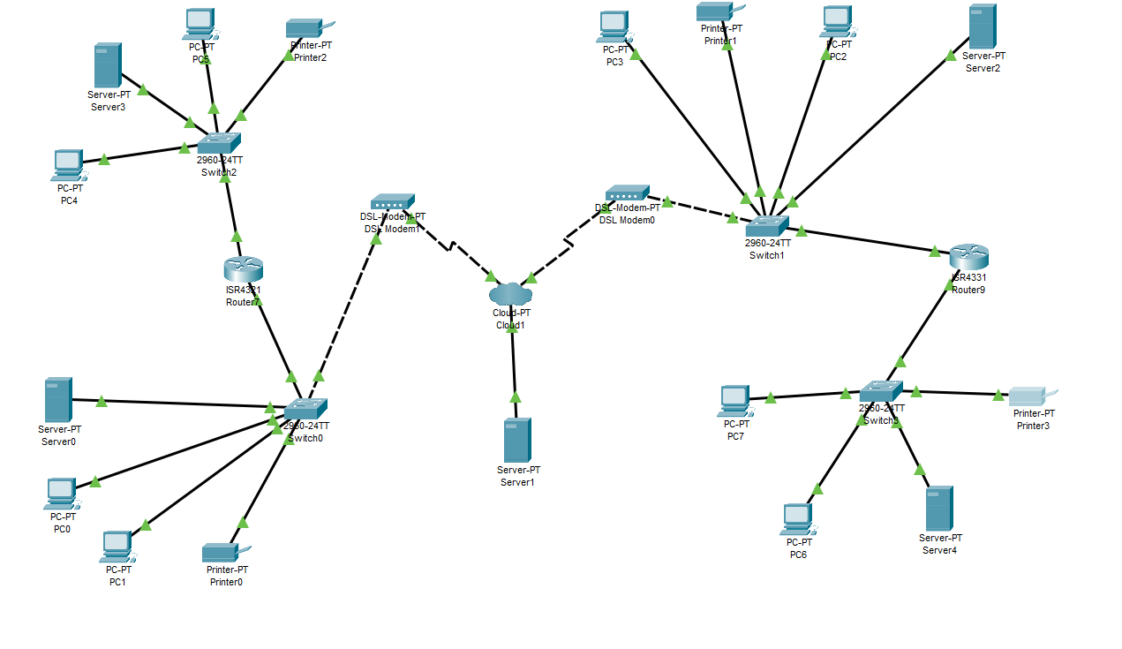

### Hardware:

|  |  |
| --- | --- |
| Computer set (ThinkCentre neo 50s Gen 4)  Total Pices: HK$5,588.00  Desc: Performance and Reliability: The ThinkCentre neo 50s Gen 4 is designed to deliver high performance and reliability, making it suitable for both personal and professional use. Its powerful hardware components ensure smooth multitasking, fast processing speeds, and efficient performance for various computing tasks. |  |
| Operation system | Window 11 |
| CPU: | Intel® Core™ i5-12400 |
| Ram | 8 GB DDR4-3200MHz (UDIMM) |
| SDD: | 256 GB SSD M.2 2280 PCIe Gen4 TLC Opal |
| Form factor | 小型尺寸 85% 功率 180W |
| Screen  PHILIPS 221V8A 22" Full HD Monitor  $869  Desc:  Energy Efficient: This screen is designed to be energy-efficient, helping users reduce power consumption and lower electricity costs.  Eye-Friendly Features: Philips incorporates eye-friendly technologies into their screens, and the 221V8A is no exception. |  |
| Keyboard & mouse  Logitech MK470 Slim Wireless Combo  $349  Desc  Slim and Compact Design: The MK470 combo features a slim and compact design, making it suitable for users who prefer a sleek and space-saving setup. The low-profile keys on the keyboard provide a comfortable typing experience, while the compact size of the mouse allows for easy portability. |  |
| network connect  (Intel AX210 PCIe Wi-Fi (Wi-Fi 6E / BT 5.3))  $399  Desc  Advanced Wi-Fi Technology: The AX210 PCIe Wi-Fi card utilizes the latest Wi-Fi 6E technology, providing users with enhanced wireless connectivity. Wi-Fi 6E offers faster speeds, higher capacity, and reduced latency compared to previous Wi-Fi standards, making it ideal for bandwidth-intensive activities such as streaming 4K videos, online gaming, and large file transfers. |  |
| Sever  ASUS RS700-E11-RS12U  $7376  Desc  High Performance: The ASUS RS700-E11-RS12U is designed to deliver exceptional performance for demanding server applications. It features powerful processors, ample memory capacity, and efficient cooling systems, enabling it to handle intensive workloads and resource-intensive tasks with ease.  requirements evolve. |  |

### Software:

|  |  |
| --- | --- |
| Visual Studio 2019 system maintenance and modification |  |
| Microsoft office  Daily business use |  |
| Operation system  Windows sever 2022 |  |
| MySQL (database control)  MySQL Enterprise Edition (On-Premises) $5350 |  |
| Adobe$2,736(per year for 1 user) |  |
| Security software  (Bitdefender Total Security)  (10 devices per year $500) |  |

Visual Studio 2019 Description:

Comprehensive Development Tools: Visual Studio 2019 provides a wide range of tools and features to support various programming languages, frameworks, and platforms. It offers integrated development environments (IDEs), code editors, debugging tools, testing frameworks, and version control integration, allowing developers to efficiently build, debug, and deploy applications.

Microsoft office Description:

Microsoft Office has a powerful suite of productivity tools. With applications like Word, Excel, PowerPoint, and Outlook, it offers a comprehensive solution for creating documents, managing data, designing presentations, and organizing emails. Microsoft Office provides a familiar and user-friendly interface, extensive collaboration features, and compatibility across devices. It enables professionals, students, and individuals to enhance their productivity, streamline workflows, and create polished and professional-looking documents, making it a must-have software for personal and professional use.

Windows sever 2022:

its robust and reliable server operating system. It offers advanced security features, improved performance, and scalability. Windows Server 2022 provides a secure platform for running critical applications and managing datacenters. It supports hybrid cloud integration, enabling seamless connectivity between on-premises and cloud environments. With enhanced containerization and virtualization capabilities, it allows for efficient resource utilization. Windows Server 2022 is a trusted choice for businesses seeking a stable and scalable solution to support their server infrastructure and ensure smooth operations.

MYSQL Description

MySQL has a powerful and reliable open-source database management system. MySQL offers excellent performance, scalability, and high availability, making it ideal for handling large datasets and complex applications. It supports multiple platforms, provides strong data security, and offers robust features like replication, clustering, and transactional support. With a large and active community, MySQL benefits from continuous development and support

Adobe Description:

Adobe software for its industry-leading creative tools and solutions. Adobe offers a comprehensive suite of applications like Photoshop, Illustrator, InDesign, Premiere Pro, and more. These tools empower professionals and creatives to design graphics, edit photos and videos, create stunning visual effects, and develop engaging digital content. Adobe software provides advanced features, intuitive interfaces, and seamless integration between applications. With regular updates and a vast creative community, Adobe remains the go-to choose for individuals and organizations seeking powerful software to bring their creative visions to life.

Bitdefender Total Security Description:

Bitdefender Total Security has comprehensive and robust cybersecurity protection. It offers advanced features like real-time threat detection, multi-layered defense against malware, secure web browsing, and a firewall. Bitdefender Total Security safeguards personal data, protects against online threats, and secures privacy across multiple devices. With its user-friendly interface and minimal impact on system performance, Bitdefender Total Security provides peace of mind and a reliable defense against cyberattacks, making it an essential choice for individuals and families looking to protect their digital lives.

Price counting:

Hardware

|  |  |  |  |
| --- | --- | --- | --- |
| name | price | quantity | Total price |
| computer | 5588 | 50 | $279400 |
| Keyboard & Mouse | 349 | 50 | $17450 |
| network connect | 399 | 50 | $19950 |
| sever | 7376 | 20 | $147520 |
| overall |  |  | $464320 |

Suppose there are 40 devices required for security, 30 devices required Adobe and other 20 devices required the OS, server and the visual studio.

Software price: **(Total price is calculated for buy that software per year)**

|  |  |  |  |
| --- | --- | --- | --- |
| Name | price | quantity | Total price |
| Visual Studio | HK350 |  | $350 |
| Microsoft office | 97.75/month | (buy for one year) | $1173 |
| Operation system  Window server | $5,970 | 20 | $119400 |
| MySQL | $5350 |  | $5350 |
| Adobe | $2,736/user | 30 | $8208 |
| Security software | 10 devices per year $500 | 40 | $20000 |
| overall |  |  | $154475 |

Total price of buying all required software and hardware:154475 + 464320 = 618795

This is just a purposed total price for all main company in Chinna, if all the company in China are require those software and hardware, the price may increase for 30%-40%. The price is case sensitive for the company if the company does not require to install the system to all company, just some selected company will install the new system, then the price will be reduced.

## 5.2 How can an organization get benefit from this central computerized

**1.Improved Efficiency:**

A centralized system streamlines processes and eliminates redundant tasks. It provides a unified platform for managing various activities, such as inventory management, customer relationship management, human resources, financial operations, and more. By automating and integrating these processes, it reduces manual effort, minimizes errors, and enhances overall efficiency.

**2.Better Customer Service:**

With a centralized system, customer data and interactions can be consolidated, providing a holistic view of customer relationships. This enables organizations to deliver more personalized and efficient customer service. Customer inquiries and issues can be handled more effectively, as relevant information is readily available to customer service representatives. This leads to improved customer satisfaction and loyalty.

**3.Enhanced Data Accuracy:**

With a centralized system, data is stored in a single database, ensuring consistency and accuracy. Information can be updated in real-time, and changes are reflected across the organization, eliminating data discrepancies or version control issues that may arise with multiple disparate systems. Accurate and up-to-date data improves decision-making and reduces the risk of errors.

**4.Cost Savings:**

While implementing a centralized system may involve an initial investment, it can lead to long-term cost savings. By eliminating the need for multiple standalone systems, organizations can reduce hardware, software, and maintenance costs. Additionally, centralized systems streamline processes, reduce errors, and improve efficiency, resulting in operational cost savings over time

For those improvements are main solve the human error and data using. Most of the original policy in LC an LMC are less effective for data processing and human error. Both issues will affect the company operation and benefit but for using the new system those problem will improve or solute. For using the new system, the re-order, DI and danger level problem checking can solute by using the new system. Reduce the manual error, damage and accident. Improve the company competitiveness in the market.

And for the customer service part, the system creates a reply system, whenever the customers send the order, the system will reply to a soft copy invoice by mail as a double confirmation. Increase the user experience and lend a good and responsible impression. Furthermore, the system will remind the customer that we have insufficient stock and it require more time for the order. Eventually the stock will be sending a message to the customers that the order is complete and send a soft copy invoice and hard copy to the customers. Improve the company impression. As a long-term development, A good company serviceable impressions is the most importance part, just like a snowball effect.

## 5.3 Constraints and Limitations

•Regulatory policies

The company must adhere to specific regulatory policies related to the assembly, distribution, and trading of motor cars in the PRC market. These policies impose constraints on various aspects of the business operations, such as data privacy, product safety standards, and compliance with local laws and regulations. The system may not be detecting all process is illegal or not.

And the system will keep the account record but not completely all data or information of the account. The system that we are building is focus on business work, not for data recording management, therefore the system will not cover all the account data and record completely.

In the system compatibility side, the system will not supporting other Operation system such as Mac OS or Linux. The system only accepts the window OS for the daily operation at all. If there are any staff are using their own laptop for their work, there may have compatibility issues.

And also, the system will only work on the company computer as well. Based on the data protection and personal data issues, the system will not work in any other computer. If there are any staff want to login system for data checking, they can only use the computer in the company. The system that we are developing is only suitable for the company assigned computer, we are not going to develop and mobile system for the company, there may have some inconvenience issues.

•Hardware limitations

Based on the company financial problem, the new hardware is not the best choose for the company, the hardware we choose is consider about the quality-price ratio. For the operating system, it is sufficient but there may have some delay when the system is processing.

Also, the hardware physical protection may not be sufficient at all because those hardware will be affected by the environment and manual factor. when we are considered about the system and hardware, we have not considered manual issues which led the hardware is damage. If there are any damage form the hardware, company may hard to fix the data and all the hardware are require replacing.

In the other side, we have not considered about the company space at all, for installing all the hardware into the company, those hardware are require a certain extend space. If the company do not have enough space to install all the hardware, then the company may need to change the hardware requirements or find other suitable method.

•Audit functions

To ensure accountability and transparency, the system should include robust audit functions. Limitations in the current system might restrict the ability to track and monitor activities accurately, potentially impacting the ability to identify errors or fraudulent activities.

For other side, the system is focus on the business using, increase market sharing and benefit. Therefore, the system has contained part of the audit function buy not comprehensive. The database will record all the stock outcome and income and the system will keep help the staff to update the record and reorder. But our system will not contain some automatic audit or recording functionality. The system is required to record or audit by manual support. And there is not any AI support for the system and database.

And, for the system account data management. The system may have limited capabilities to log and track user activities, making it difficult to trace and identify specific actions taken by users. The system will not capture the account any online record, browsing history and contact information. The system will only record the system using record. If the user does not use the system account, then the system will not record or capture any other online record.

The level of detail captured in audit logs may be inadequate because of the challenge of the system and the company situation. The system has not considered about these issues. And Insufficient granularity will limit the ability to determine the sequence of events or identify the root cause of an issue

•Reliability requirement

The system will be suitable for window and there is some software is able to record some system data, but the system has not considered the Downtime and System Failures. The system window in not consider window system experience frequent downtime or system failures and it may lead disruptions in business. And the system may not have enough functionality or ability to process the operation system error.

The system may encounter performance bottlenecks during peak usage periods or when handling large volumes of data. This can lead to slow response times, causing inefficiencies and frustration for users and potentially impacting the timely processing of orders and stock updates.

The system has lack redundancy and fault tolerance mechanisms, making it vulnerable to single points of failure. In the event of hardware or software failures, there may be limited backup systems or failover capabilities, leading to extended periods of system unavailability and potential data loss. And based on the system develop, the IT department ability and company financial situation. It may be an effectively way by using a new and complex system.

•Criticality of the application

The system will not help the user to log out even the user is not using the system. Most of the time, the system is required to log out by the user. We have not developed any automatic logout function. For the user data, file and the data base are required to protect by the user. If all the user will logout and protect their own data, then it will not be a problem.

Due to the situation that we do not have the company sales and stock need data, then we cannot ensure that the system can process a huge data in a brief time. And base on the hardware and software, when the system is required to update, maintenance or process a huge data, the system may lead to potential disruptions in critical business functions during system failures or maintenance windows. This can result in significant downtime and impact the ability to process orders, manage stock, and serve customers in a timely manner.

The system has not considered about the comprehensive disaster response plan in place. This can hinder the ability to quickly recover from critical incidents, resulting in extended downtime, increased recovery time, and potential negative impacts on customer service and business operations.

•Safety and security considerations

Based on the Security software, it can ensure certain protection but Security software, like any other software, can have vulnerabilities that attackers can exploit. These vulnerabilities may arise from coding errors, design flaws, or outdated components. If not promptly addressed through patches or updates, they can be exploited by malicious actors to gain unauthorized access or compromise the system. Therefore, we cannot ensure that the system will not be hacked or attacked but in most situations the security software can process.

When the system is being attack or hack, the system requires manual notify to another department. The system will not notify all department. This limitation introduces delays and potential communication gaps during critical security incidents. Manual notification processes can be prone to human error, delays, and overlooking specific departments, resulting in slower response times and a lack of awareness among relevant stakeholders. It may impede the ability to take immediate action, coordinate efforts, and implement necessary security measures to mitigate the attack's impact.

## 5.4 System Analysis and Design

### ▪ Actor Description, Use case diagram and description

|  |
| --- |
| Actor: dealer |
| Description:  Dealers interact with the Sales Office to place orders using channels like post, phone, telex, fax, or verbal instructions. There is no standard form, and the Sales Office follows up on all orders, including those with missing details. Each order is allocated a LM serial number, and the Order Processing Clerk inputs the order contents into the computer system |
| Actor: Sales Office Manager |
| Description: Responsible for supporting the selling force by processing dealer's orders and issuing instructions for the dispatch of spares. Able to check the employee file, the order process tempo and database |
| Actor: Sales Office staff |
| Description:  Responsible for supporting the selling force by processing dealer's orders and issuing instructions for the dispatch of spares but the permission is less then manager |
| Actor: Order Processing Clerk |
| Description:  Inputs the contents of the orders into the computer system and communicate with the dealer |
| Actor: Area Manager |
| Description:  Controls a selling force that makes regular calls to dealers in a specific sales area. |
| Actor: Storemen |
| Description:  Work in the spare parts store and pick items from the bins based on the DI sets received. |
|  |
| Actor: Storemen manager |
| Description: Work in the spare parts store and pick items from the bins based on the DI sets received. Able to create user account, check database and have permission to modify data |
| Actor: Stock Record Clerk |
| Description:  Maintains stock records, records inward and outward items, and calculates new book stock balances. |
| Actor: Stock Record Manager |
| Description:  Maintains stock records, records inward and outward items, and calculates new book stock balances. And have the permission to create or modify the user account, check database and modify data |
| Actor: Purchasing Department staff |
| Description:  Responsible for purchasing stock based on re-order cards, danger cards, and out-of-stock cards. |
| Actor: Purchasing Department manager |
| Description:  Responsible for purchasing stock based on re-order cards, danger cards, and out-of-stock cards. Able to create or modify user account, check all the re-order message and update the stock database. |
| Actor: Invoicing Section |
| Description:  Handles the invoicing process and reconciles invoices with delivery notes. |
| Actor: Deliveryman |
| Description:  Carries the delivery notes and obtains signatures from dealers upon delivery. |
| Actor: Goods Inward Department |
| Description:  Sends Good Received Notes (GRNs) for incoming items |
|  |
| Actor: IT department staff |
| Description:  daily hardware and software maintenance. Process different department IT issues. Process the user account data. Receive the department requirement and process |
| Actor: IT department manager |
| Description: daily hardware and software maintenance. Process different department IT issues. Process the user account data, able to view the database situation and process the account deletion and modification. |
| Actor: |
| Description: |

Use Case 01 (order Process)

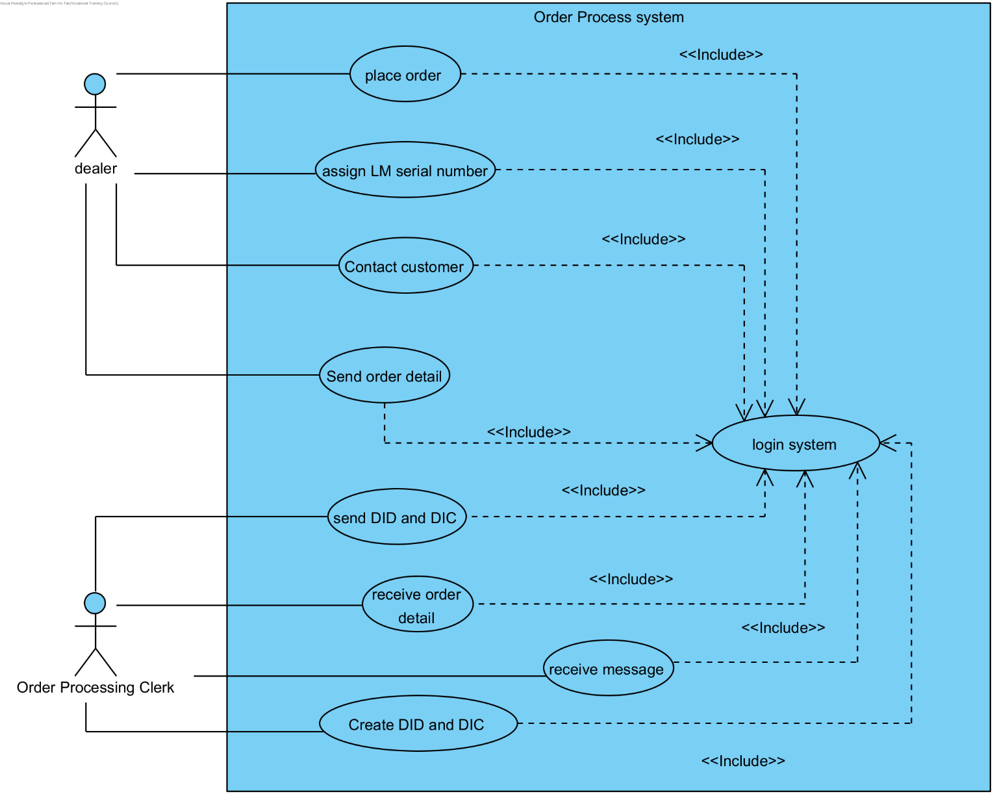

DI process Use case (UC_02)

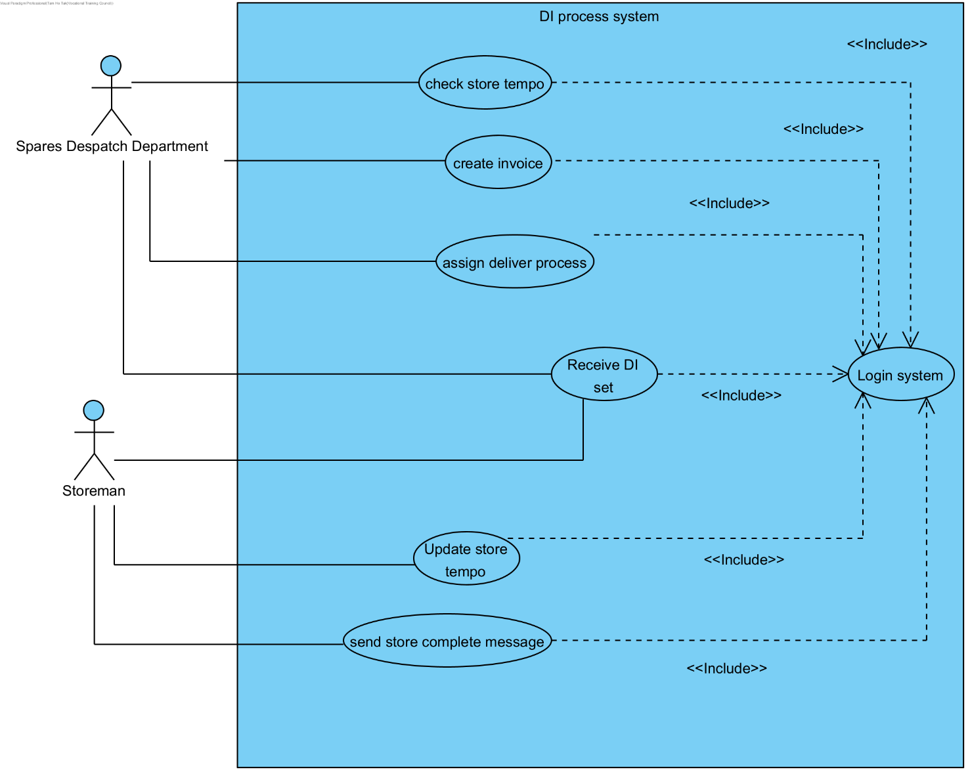

Login Use case UC_03

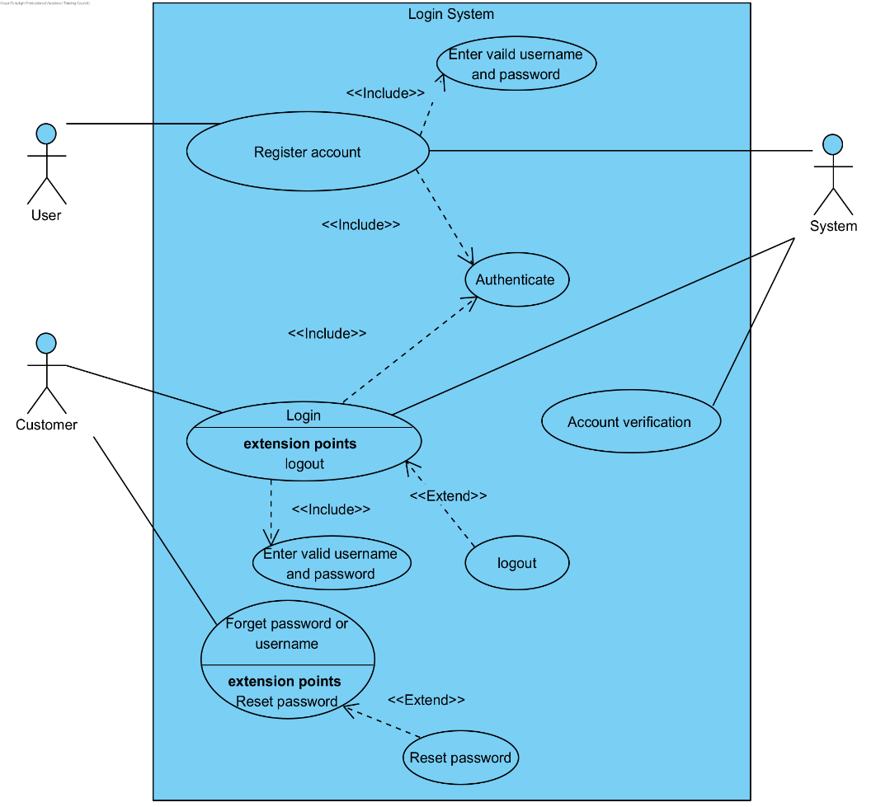

Login data management Use Case: UC_04

Invoice process UC_05

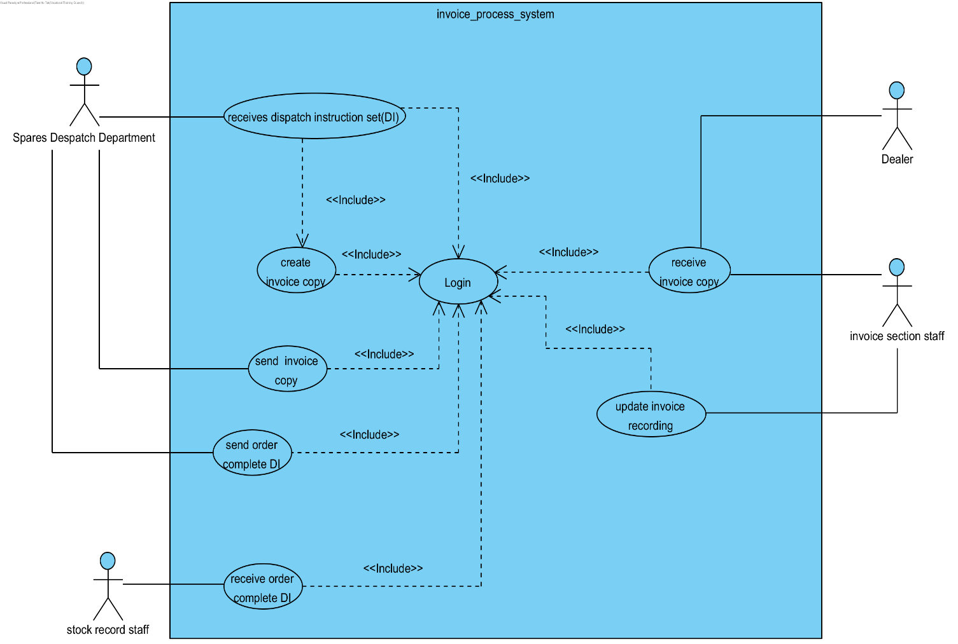

Reorder process (UC_06)

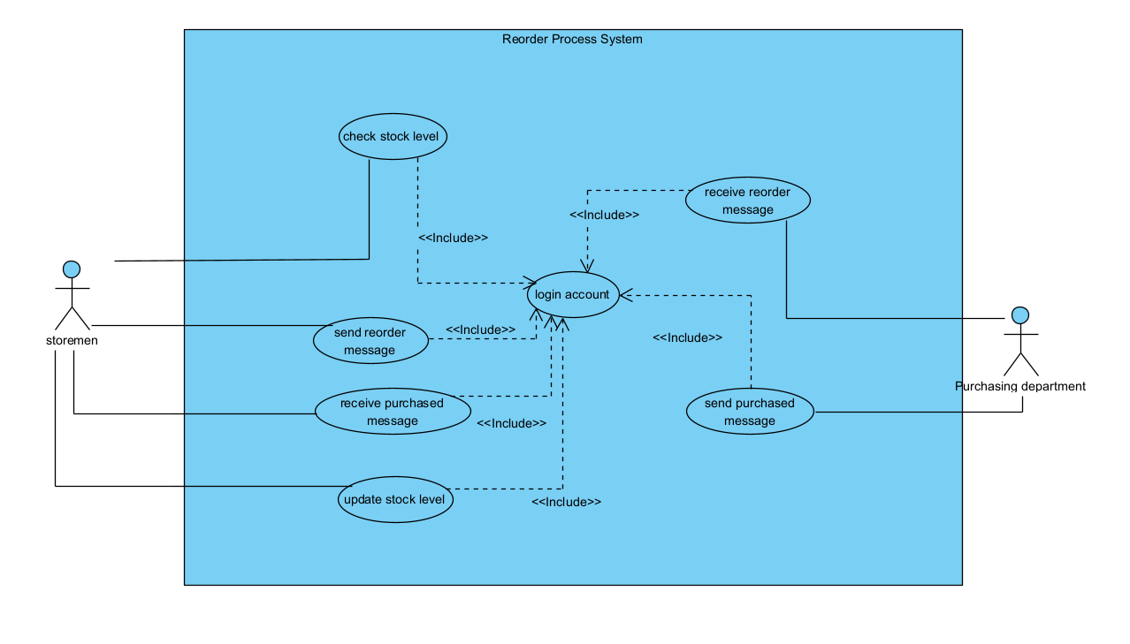

Danger level Use case (UC_07)

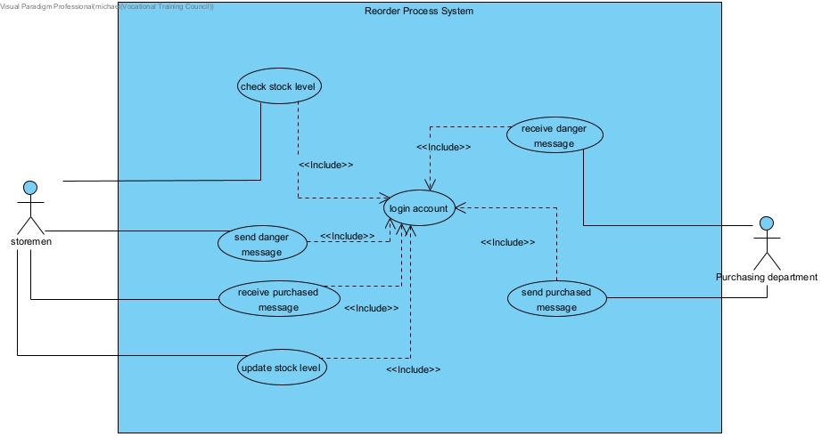

Use Case formal:

Login

|  |  |
| --- | --- |
| Use case name: | Order Process |
| Use case ID | UC_01 |
| Primary Actor | Dealer |
| Secondary Actor(s) | customer |
| Brief description | This is the process when there is a customer contact with the dealer and place the order that what the customer want |
| Pre-condition | Dealer and order process processing clerk login the system |
| Post-condition | The customer has already ordered the stock and the dealer have recorded |
| Flow of event | * 1. Dealer login into the system * 2. Drow down all the stock that have been order by the customer * 3. assign the LM serial number for the order * 4. Send the order detail and the LM serial number as a message to the order processing clerk * 5. the order processing clerk receive the message * 6. order processing clerk based on the message to create the DIC and DID to other require department. |
| Alternative flow and exceptions | When the dealer has missed some order detail, dealer can contact back to the customer.  The system can provide relevant stock data |
| Priority | Medium |
| Non-behavior requirement | The system can process the error input data |
| Assumption | All staff have permission to create the DID and DIC or process the order creation |
| Issues | None |
| Source |  |

|  |  |
| --- | --- |
| Use case name: | DI process |
| Use case ID | UC_02 |
| Primary Actor | Spares Despatch Department staff |
| Secondary Actor(s) | Storeman |
| Brief description | This is the process of the DI when there are any DI set is pass by the dealer and how the order is process by using the DI |
| Pre-condition | Spares Despatch Department staff and storeman both have login the system. |
| Post-condition | Dealer has sent the DI set to the Spares Despatch Department |
| Flow of event | 1. Spares Despatch Department staff has login the system 2. Spares Despatch Department staff receive the DI message 3. Spares Despatch Department staff pass the DI require stock to the storeman 4. Storeman keep storing the stock and update the tempo into the system 5. When the storing is complete, storeman send the store complete message to the Spares Despatch Department and deliver the packaged stock to the Spares Despatch Department 6. Spares Despatch Department staff receive the storing complete message and the package of the stock 7. When the Spares Despatch Department received the stock, the staff will create the invoice for the DI and package stock 8. Assign deliver process for the dealer. |
| Alternative flow and exceptions | When there is insufficient stock, storeman can contact the Spares Despatch Department for prolong storing time. |
| Priority | medium |
| Non-behavior requirement | The system can process the message sending immediate and there is any error sending the system will notify the sender |
| Assumption | All storemen can update the tempo and the Spares Despatch Department staff check or see all the message. |
| Issues | None |
| Source |  |

|  |  |
| --- | --- |
| Use case name: | Login Data Managment |
| Use case ID | UC_04 |
| Primary Actor | Department Manager |
| Secondary Actor(s) | IT department |
| Brief description | This is the process of the login account management by different actor |
| Pre-condition | Managers have login to their own account in the system |
| Post-condition | Those managers have permission to create the new account or modify account permission to different staff |
| Flow of event | 1. Manager login the system 2. Select option create new account or modify account 3. Insert the user ID of the account and select modify option 4. When the manger wants to modify permission then select the permission level only can process the order, view data base or able to modify file and permission 5. Select the correct option 6. Then the system will display the modifying account data and permission level 7. If nothing wrong, then manager push save bottom 8. The account data and account database will be update |
| Alternative flow and exceptions | If manager want to create a new account, then follow the step to step 2 and select create account, and then the system will ask create reason, account owner name, owner employee ID, password and permission level setting. If all the data is insert correctly, then the system do step 6 to 8  Other case, if the manger wants to delete or block the account, the manager needs to contact with IT department, and describe the delete or block reason, then the ID department will start the process  Eventually the account delete action, or block will be written down as a report. |
| Priority | high |
| Non-behavior requirement | The system can identify different account permission and limit account by the account permission |
| Assumption | Account will not be modified, delete or overwrite by any reason without IT department |
| Issues |  |

|  |  |
| --- | --- |
| Use case name: | Invoice process |
| Use case ID | UC_05 |
| Primary Actor | Spare despatch department staff |
| Secondary Actor(s) | Stock record staff, invoice section staff and dealer |
| Brief description | This is the step of the invoice processing and what actor will use the invoice |
| Pre-condition | All staff have login into the system |
| Post-condition | The require stock has been ordered and packaged |
| Flow of event | 1. The Spare despatch department staff login the system 2. Receive the order assemble complete message and the DI 3. Based on the DI set and use the system to create 4 invoice copy 4. Record on copy as hard copy as record 5. Send invoice copy to dealer as record 6. Send invoice copy to the stock record staff as record 7. Send the invoice copy to the invoice section for update invoice record |
| Alternative flow and exceptions | All invoices will send to all department or staff complete and the invoice copy will record as well |
| Priority | medium |
| Non-behavior requirement | The system can process all invoices copy for creation or recording. |
| Assumption | The stock has assembled and there are enough data for create the invoice |
| Issues |  |

|  |  |
| --- | --- |
| Use case name: | Reorder Process |
| Use case ID | UC_06 |
| Primary Actor | Storemen, Purchase department |
| Secondary Actor(s) |  |
| Brief description | This is the step of the reorder processing and what storemen will use while reordering |
| Pre-condition | storemen, purchase department login the system |
| Post-condition | The reorder form is created |
| Flow of event | 1. The storemen login the system 2. Check stock level 3. One or more item reach reorder level 4. Select reorder function 5. Give reorder items details to system 6. Confirm reorder |
| Alternative flow and exceptions | Step 3 will not execute if stock level did not reach reorder level |
| Priority | high |
| Non-behaviour requirement | There are at least one or more items that reach reorder level. |
| Assumption |  |
| Issues | Items may not exist |

|  |  |
| --- | --- |
| Use case name: | Danger level |
| Use case ID | UC_07 |
| Primary Actor | Storemen, Purchase department |
| Secondary Actor(s) |  |
| Brief description | This is the step of the item stock reach danger level and what storemen will use |
| Pre-condition | storemen, purchase department login the system |
| Post-condition | The purchase order is created |
| Flow of event | 1. The storemen login the system 2. Check stock level 3. One or more item reach Danger level 4. Select purchase function 5. Give items details which in danger level to system 6. Confirm purchase |
| Alternative flow and exceptions | Step 3 will not execute if stock level did not reach danger level |
| Priority | high |
| Non-behavior requirement | There are at least one or more items that reach danger level. |
| Assumption |  |
| Issues | Items may not exist |

### ▪ Class Diagram (Design Level)

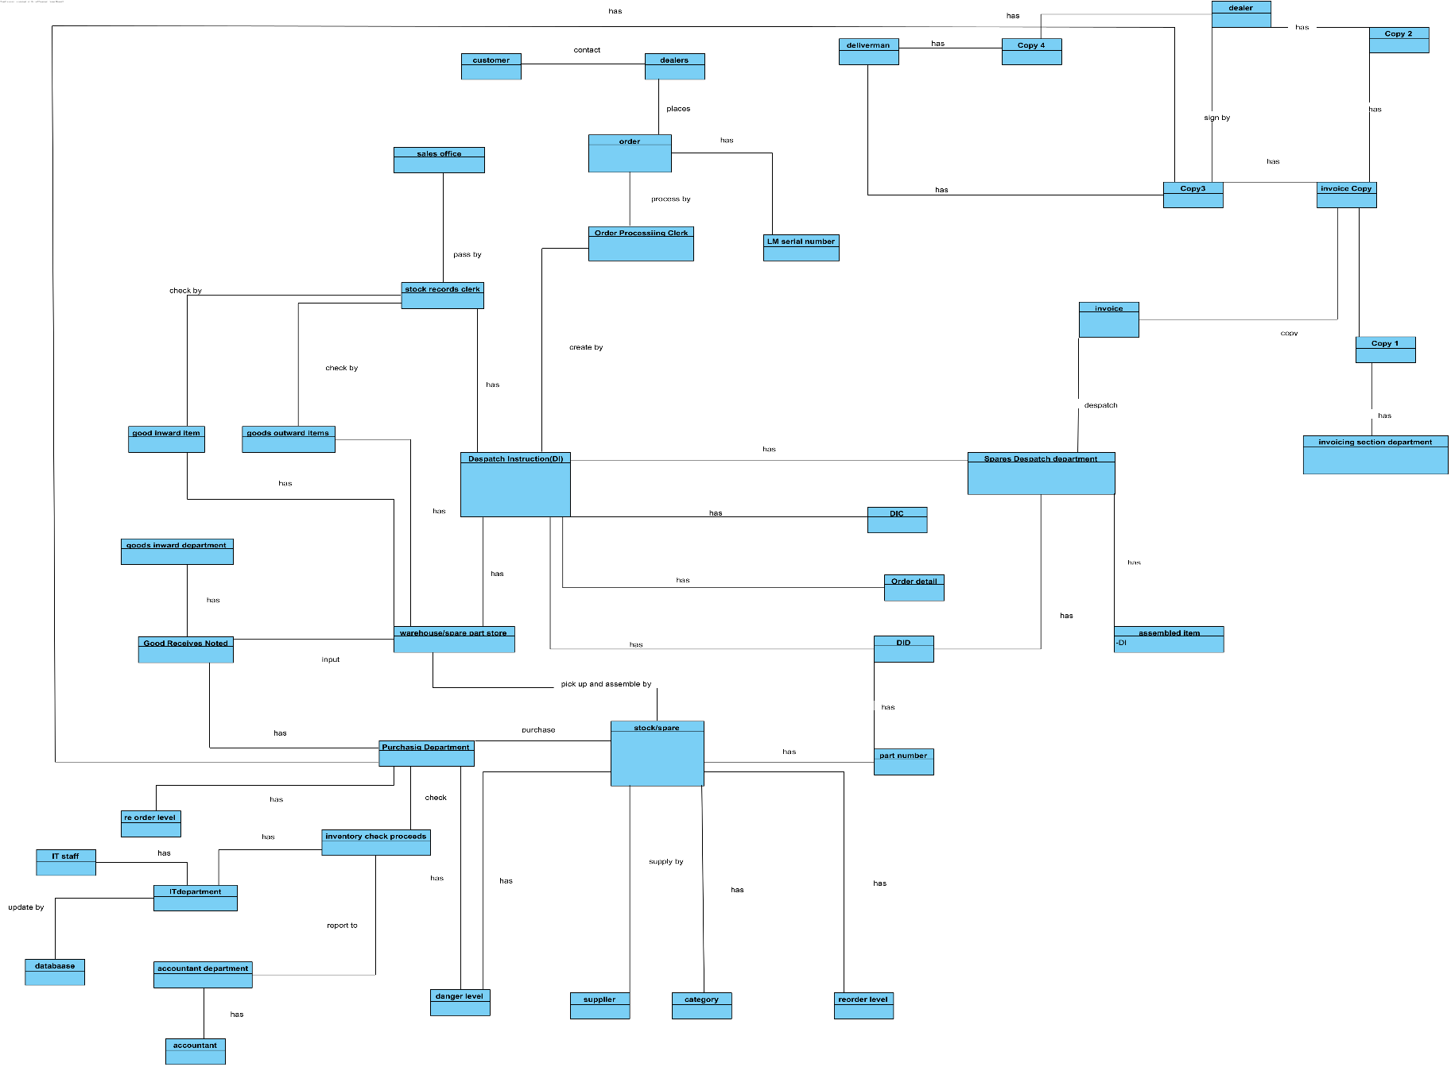

### ▪ Sequence Diagram (3-Tier with MVC model)

Login account creation sequence diagram:

田

Account permission or data modification sequence diagram

use

|  |
| --- |
| Place Order sequence diagram |
|  |

Invoice process sequence diagram

Reorder process sequence diagram

Danger level sequence diagram

### ▪ State Machine Diagram (if necessary)

|  |
| --- |
| Entity Relation Diagram (ERD) |
|  |

## Detailed Database Design which clearly shows name, data type and brief

## description of primary keys, foreign keys and all other attributes.

Table: Customer

|  |  |  |  |  |
| --- | --- | --- | --- | --- |
| Column Name | Datatype | Key? | Null? | Description |
| CusID | char (8) | PK | No | Customer ID. |
| Password | varchar (50) |  | No | The password for the system. |
| DeliveryAddress | varchar (255) |  | No | Customer address, the place order delivery to. |
| ContactName | varchar (30) |  | Yes | Customer name |
| CusPhoneNo | Integer (15) |  | No | Customer Phone Number. |
| Email | varchar (255) |  | Yes | If we have some notice, we can send by this method. |

Table: staff

|  |  |  |  |  |
| --- | --- | --- | --- | --- |
| Column Name | Datatype | PK  ? | Null? | Description |
| StaffID | char (8) | PK | No | Staff ID. |
| StaffName | varchar (100) |  | No | Staff full name. |
| DeptName | varchar (30) |  | No | Department name. |
| DepatNo | Integer (50) |  | No | Department Number. |
| JobTitle | varchar (50) |  | No | Job Title of the staff. |
| Email | varchar (255) |  | No | Staff email |

Table: Product

|  |  |  |  |  |
| --- | --- | --- | --- | --- |
| Column Name | Datatype | Key? | Null? | Description |
| ProductNo | char (10) | PK | no | Spare Part Number. |
| ProductName | varchar (255) |  | no | Each spare part's name. |
| QtyInStock | Integer (10) |  | no | The quantity of spare parts in stock. |
| Price | double |  | no | The Price of each spare part. |

Table: Purchase_order

|  |  |  |  |  |
| --- | --- | --- | --- | --- |
| Column Name | Datatype | Key? | Null? | Description |
| OrderNo | Integer (20) | PK | no | Order Number. |
| LMSerial Number | char (20) |  | no | Legend Motor Serial Number. |
| StockID | char (20) |  | no | Assigned stock ID for each type of stock and it will be record in database |
| StockName | varchar (255) | FK | no | Each name of the product |
| OrderDate | date |  | no | Place order date.  Format: DD-MM-YY |
| OrderSerial | Integer (10) |  | no | The serial number of orders. |
| DeliveryAddress | varchar (255) |  | no | Delivery address of customer. |
| ProductNo. | varchar (8) | FK | no | Spare part number.  Format: A0000001  B0000001  C0000001  D0000001 |
| OrderQty | Integer (10) |  | no | The quantity of each spare part |
| Price | Numeric (9,3) | FK | no | The total price of each spare part |
| Status | varchar (50) |  | no | Describe Order status. Comple, Confirm, Shipping....... |

Table: Despatch_Instruction_Cover(DIC)

|  |  |  |  |  |
| --- | --- | --- | --- | --- |
| Column Name | Datatype | Key? | Null? | Description |
| OrderNo | Integer (20) | PK, FK | no | Order Number. |
| Date | date |  | no | The date of place order. |
| DeliveryAddress | varchar (255) |  | no | The place order will be delivered to the current address. |

Table: Despatch_Instruction_Detail(DID)

|  |  |  |  |  |
| --- | --- | --- | --- | --- |
| Column Name | Datatype | Key? | Null? | Description |
| OrderNo | Integer (20) | PK, FK | No | Order Number. |
| Date | date |  | No | The date of place order. |
| DeliveryAddress | varchar (255) |  | No | The place order will be delivered to. |
| TotalToDespatch | Integer (10) |  | No | Total number of the order dispatch. |
| Weight | numeric (8,3) |  | No | The Total weight of the order.  Format: 100.012kg |
| DispatchInstruction | varchar (255) |  | Yes | Instruction of the dispatch. |

Table: DISet

|  |  |  |  |  |
| --- | --- | --- | --- | --- |
| Column Name | Datatype | Key? | Null? | Description |
| OrderNo | Integer (20) | PK, FK | No | Order Number. |

Table: Spare_Parts_Store

|  |  |  |  |  |
| --- | --- | --- | --- | --- |
| Column Name | Datatype | Key? | Null? | Description |
| ProductNo | char (10) | PK | No | Spare part number. |
| PdQtyInStock | Integer (10) |  | No | The quantity in stock. |
| ProductName | varchar (255) |  | NO | The name of spare part. |
| Price | numeric (9,3) |  | No | The price of spare part. |
| DISetOrderNo | Integer (20) | FK | No | DI set order number. |

Table: Spare_Parts_Store

|  |  |  |  |  |
| --- | --- | --- | --- | --- |
| Column Name | Datatype | Key? | Null? | Description |
| ProductNo | char (10) | PK | No | Spare part number. |
| QtyInStock | Integer (10) |  | No | The quantity in stock. |
| ProductName | varchar (255) |  | NO | The name of spare part. |
| Price | numeric (9,3) |  | No | The price of spare part. |

Table: Supply

|  |  |  |  |  |
| --- | --- | --- | --- | --- |
| Column Name | Datatype | Key? | Null? | Description |
| ProductNo | char (10) | PK | No | Spare part number. |
| Price | numeric (9,3) |  | No | The price of spare part. |
| ProductName | varchar (255) |  | NO | The name of spare part. |

Table: Stock_Record

|  |  |  |  |  |
| --- | --- | --- | --- | --- |
| Column Name | Datatype | Key? | Null? | Description |
| ProductNo | char (10) | PK | No | Spare part number. |
| Quantity | Integer (10) |  | No | The price of spare part. |
| ProductName | varchar (255) |  | NO | The name of spare part. |

Table: InvoiceSet

|  |  |  |  |  |
| --- | --- | --- | --- | --- |
| Column Name | Datatype | Key? | Null? | Description |
| OrderNo | Integer (20) | PK | no | Order Number. |
| ProductNo | char (10) | FK | No | Spare part number. |
| QuantityDelivered | Integer (10) |  | No | The price of spare part. |
| ProductName | varchar (255) |  | NO | The name of spare part. |
| Date | date |  | No | The date delivered. |
| InvoiceAddress | varchar (255) |  | No | The invoice from. |
| DeliveryAddress | varchar (255) |  | No | The place order will be delivered to. |

Table: Copy1,4

|  |  |  |  |  |
| --- | --- | --- | --- | --- |
| Column Name | Datatype | Key? | Null? | Description |
| OrderNo | Integer (20) | PK, FK | No | Order Number. |

Table: Copy2,3

|  |  |  |  |  |
| --- | --- | --- | --- | --- |
| Column Name | Datatype | Key? | Null? | Description |
| OrderNo | Integer (20) | PK, FK | No | Order Number. |

Table: Copy2,3

|  |  |  |  |  |
| --- | --- | --- | --- | --- |
| Column Name | Datatype | Key? | Null? | Description |
| OrderNo | Integer (20) | PK, FK | No | Order Number. |

Table: ShipMan

|  |  |  |  |  |
| --- | --- | --- | --- | --- |
| Column Name | Datatype | Key? | Null? | Description |
| OrderNo | Integer (20) | PK, FK | No | Order Number. |

Table: Sales_Office

|  |  |  |  |  |
| --- | --- | --- | --- | --- |
| Column Name | Datatype | Key? | Null? | Description |
| DepNo | Integer (10) | PK | No | Department Number. |
| Address | varchar (255) |  | No | Department address. |

Table: Spares_Despatch_Department

|  |  |  |  |  |
| --- | --- | --- | --- | --- |
| Column Name | Datatype | Key? | Null? | Description |
| DepNo | Integer (10) | PK | No | Department Number. |
| DespatchQty | Integer (10) |  | No | Actual quantity dispatched. |
| ProductNo | char (10) |  | No | Spare part number. |

Data Code:

|  |  |  |  |  |  |  |  |
| --- | --- | --- | --- | --- | --- | --- | --- |
|  | Date  DD-MM-YY | Order -Time  (0-23:59) | Total price$ | buyer/company | Address: | Ordered stock  A to D (0000001) | Order-processor  .ManagerNo |
| EX. | 13-2-24 | 12:30 | $203455 | Cris Wong= CW | B_M= municipality Beijing | A0000002  B0000005  C0000002 | DS_001 |

Output= 13-2-24/12:30//$203455:C_W::M_B_w1_ A0000002#DS_001

B0000005

C0000002

Description:

for the date part the first two digit mean the Date and their will have two – to separate the next four-digit which between month and year. For the next part order time there will have one / to separate this part and for the timing it is using 24-hour clock as marking. Next, there will have a // as a separate. For the next 10 digit is the total price of the order. For the separator to the next part is “:”. And then the next part is the deliver address use the first English alphabet of the city and then add _ to separate the next digit which is the provinces in China such as B mean Beijing and the M mean Municipality, Province Liaoning will display as L_P, it depends on different place. For the separator to the next part is _. The last second part is the ordered product ID, 4 distinct types of products will be classified to be A, B, C and D. and there will have 6 number digits. for the last separator is #. And the last data code is the stuff ID who is the last one process the order.

# 5. How can an organization get benefit from this central computerized

**1.Improved Efficiency:**

A centralized system streamlines processes and eliminates redundant tasks. It provides a unified platform for managing various activities, such as inventory management, customer relationship management, human resources, financial operations, and more. By automating and integrating these processes, it reduces manual effort, minimizes errors, and enhances overall efficiency.

**2.Better Customer Service:**

With a centralized system, customer data and interactions can be consolidated, providing a holistic view of customer relationships. This enables organizations to deliver more personalized and efficient customer service. Customer inquiries and issues can be handled more effectively, as relevant information is readily available to customer service representatives. This leads to improved customer satisfaction and loyalty.

**3.Enhanced Data Accuracy:**

With a centralized system, data is stored in a single database, ensuring consistency and accuracy. Information can be updated in real-time, and changes are reflected across the organization, eliminating data discrepancies or version control issues that may arise with multiple disparate systems. Accurate and up-to-date data improves decision-making and reduces the risk of errors.

**4.Cost Savings:**

While implementing a centralized system may involve an initial investment, it can lead to long-term cost savings. By eliminating the need for multiple standalone systems, organizations can reduce hardware, software, and maintenance costs. Additionally, centralized systems streamline processes, reduce errors, and improve efficiency, resulting in operational cost savings over time

For those improvements are main solve the human error and data using. Most of the original policy in LC an LMC are less effective for data processing and human error. Both issues will affect the company operation and benefit but for using the new system those problem will improve or solute. For using the new system, the re-order, DI, and danger level problem checking can be solute by using the new system. Reduce the manual error, damage, and accident. Improve the company competitiveness in the market.

And for the customer service part, the system creates a reply system, whenever the customers send the order, the system will reply to a soft copy invoice by mail as a double confirmation. Increase the user experience and lend a good and responsible impression. Furthermore, the system will remind the customer that we have insufficient stock and it require more time for the order. Eventually the stock will be sending a message to the customers that the order is complete and send a soft copy invoice and hard copy to the customers. Improve the company impression. As a long-term development, A good company serviceable impressions is the most importance part, just like a snowball effect.

|  |
| --- |
| 6. Project schedule (grant chart) |
|  |

User Interface and Report Design

**LMC new system user interface:**

-Login system

* Login user interface

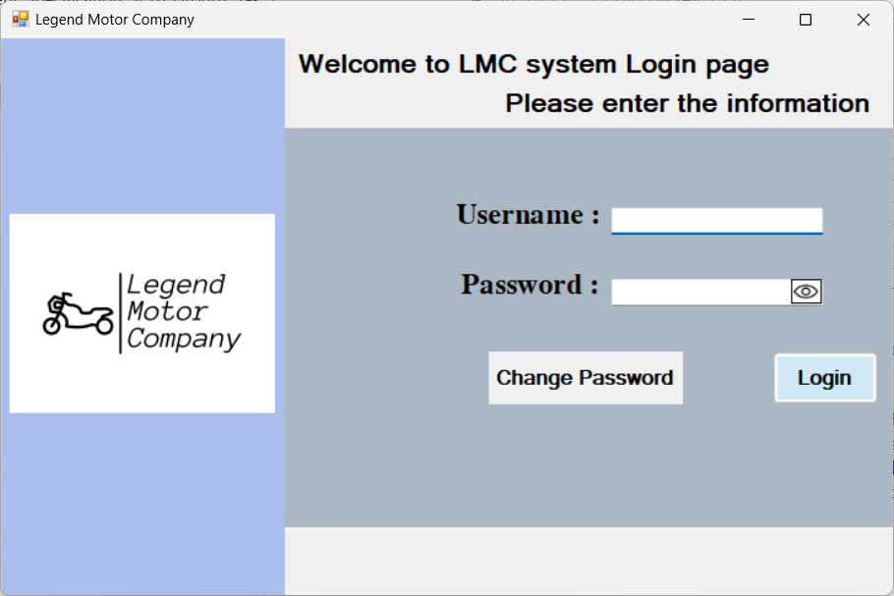

*login page must be success by insert the correct user name and password, if not account management system, Dispatch Processing system, -Salse system and Stock Record system will not open*

* Change password

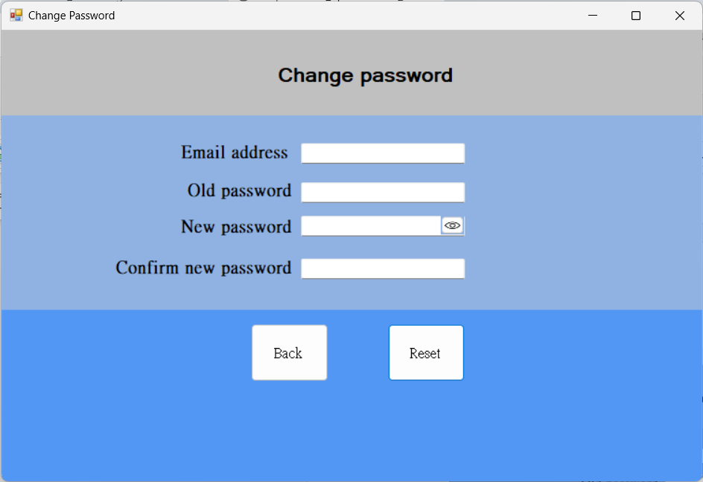

*When user wants to reset their password by clicking on the reset button under the login page. Users need to enter their email address and old password to confirm user identity. For the new password it must include the upper- and lower-case letter and number in it. After entering the information, the user needs to enter the new password two times. Lastly, the user needs to click the Reset button to reset their password and it will jump out a message box to tell user the password reset successfully.

-account management system

* Admin user interface

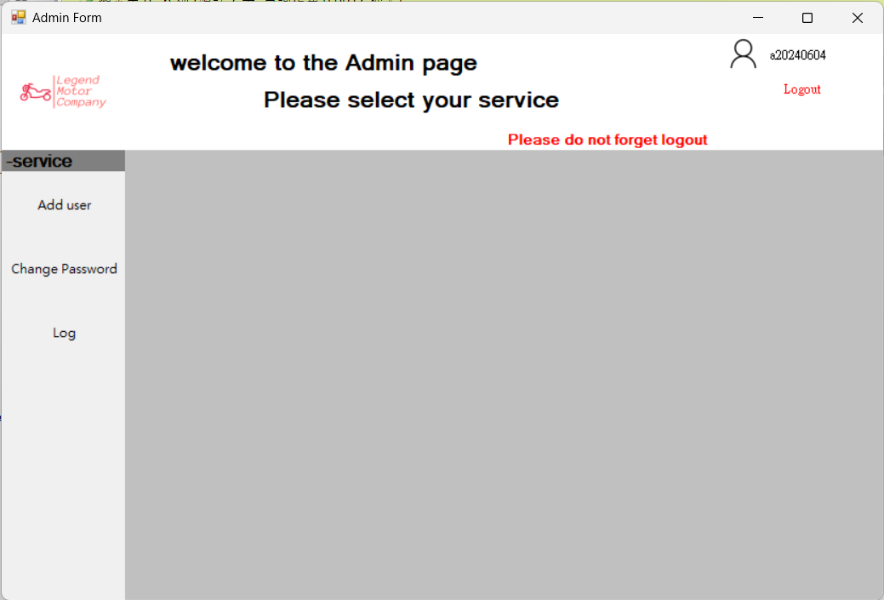

After admin login in the top right corner can see their username under the username can let user logout. In left side having a menu, admin have 3 service add user, change user password and database log.

* Add user’s user interface

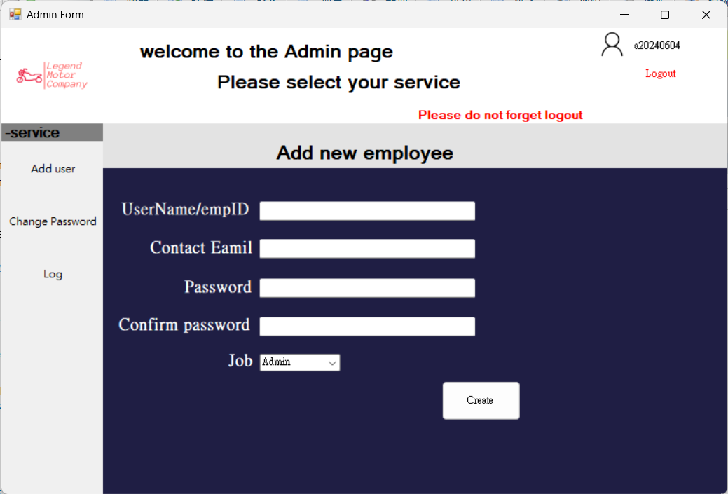

User clicks the "Add user", admin can enter the information and choose the Job of the new user. In Job there were having three types of job 1. Admin 2. Sales Manager 3. Stock Record Staff .After the user clicks the create button the system will tell user create successful, and the new user can immediately use.

* Change account Password user interface

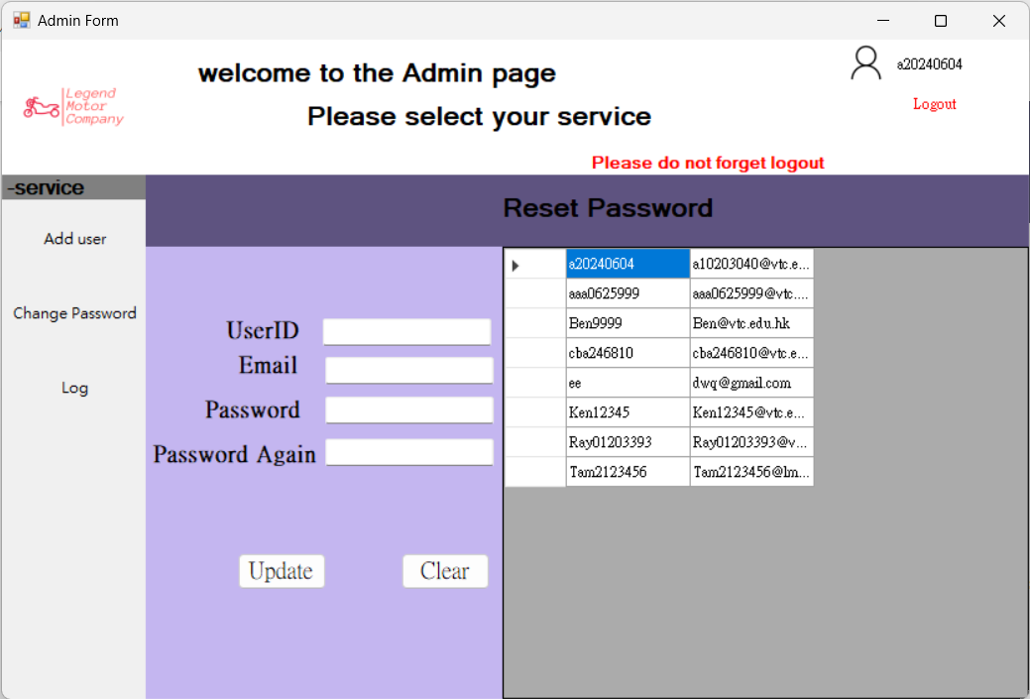

The page of this reset password is little different from the above, this page is for the user who forget their password and need admin to change. Because of security it needs to change or reset the password by the admin. In this the user can clicks the data in the right side of the screen, the data username and email address will automatically fill. After the user enters all the information and clicks the Update button it will also have a message box the told user the password was reset successfully.

* Database Log

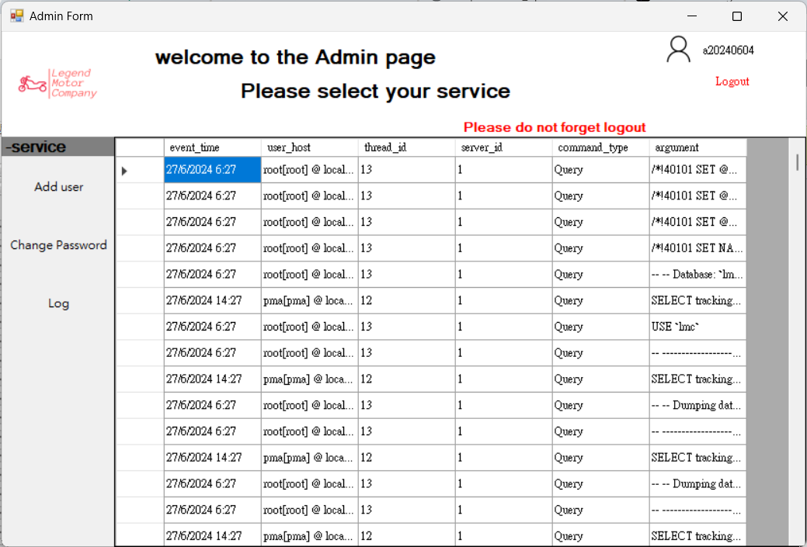

A database log is a record of activities and transactions within a database system. It helps administrators manage the system by tracking changes, aiding in auditing and compliance, facilitating recovery from failures, and enabling performance analysis and optimization. The log serves as an audit trail, allowing administrators to identify and resolve issues, ensuring data integrity and security. In case of system failures, the log assists in restoring the database to a previous state by replaying logged transactions. It also helps administrators analyze system performance, identify bottlenecks, and make necessary adjustments for optimal operation.

*This system is user for the manager to update and delete the data form different department staff*

-Dispatch Processing system

* Dispatch Note user interface

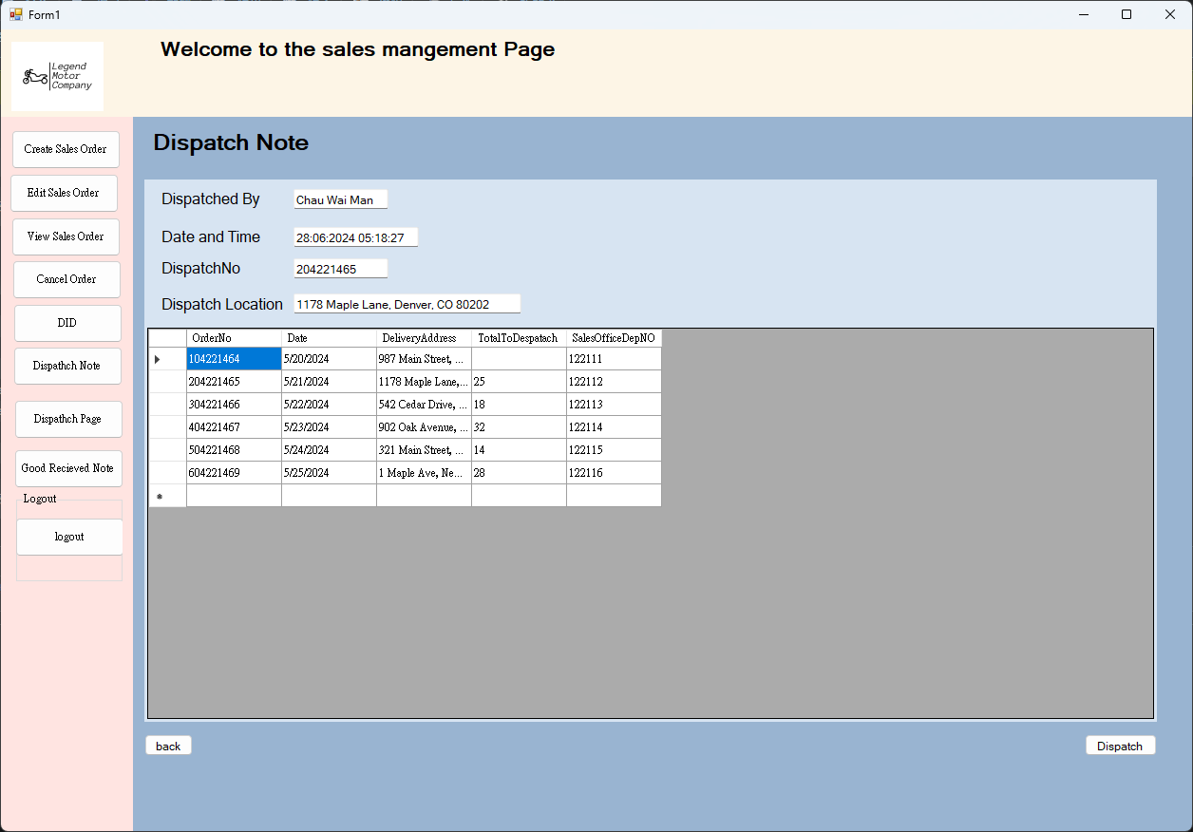

* Dispatch Page user interface

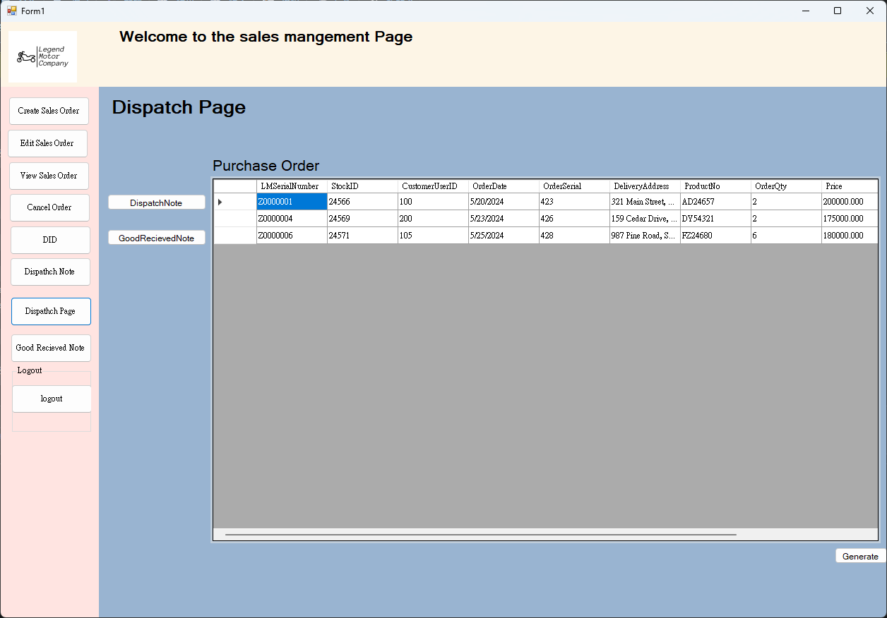

* Good Received Note user interface

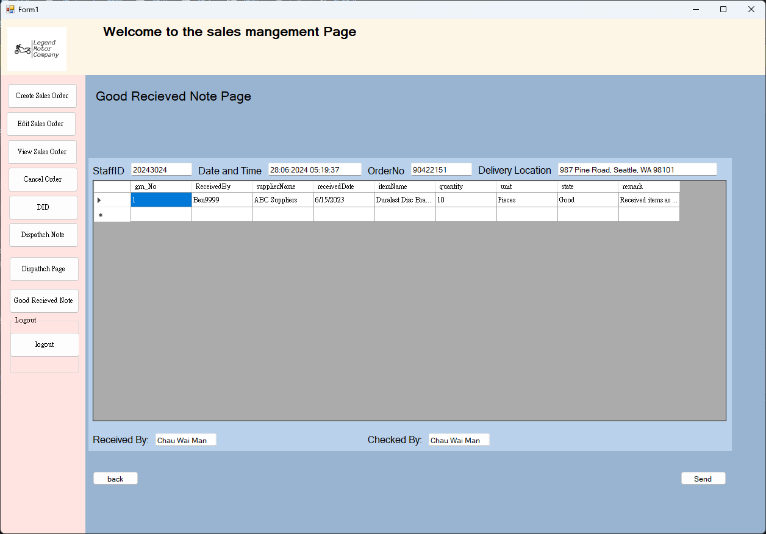

-Salse system

* Mangement Page

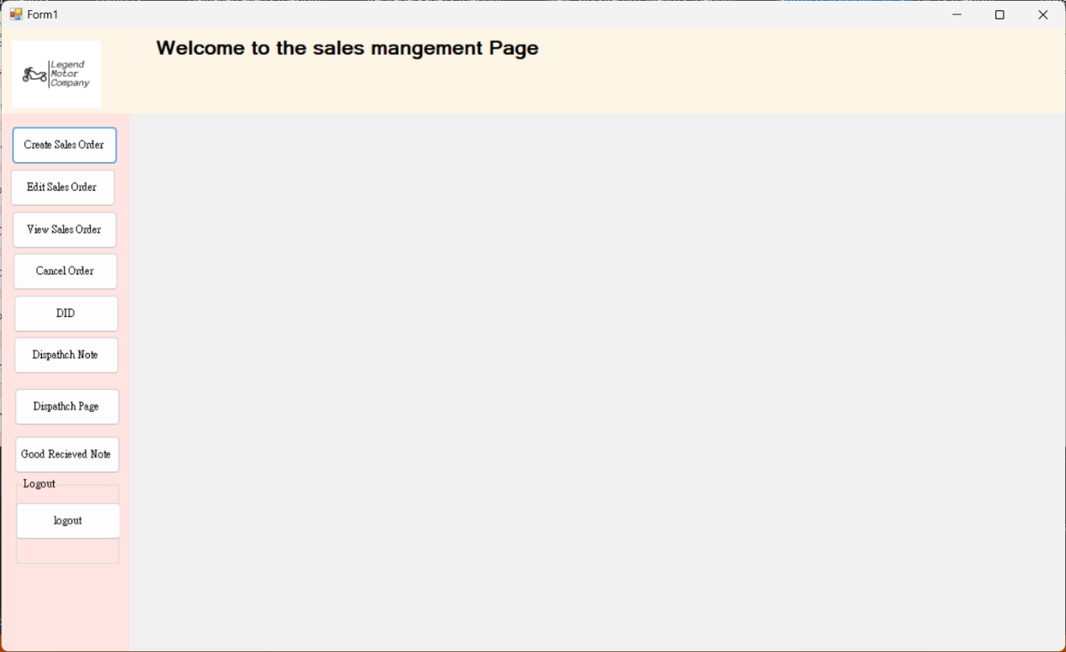

This is the main page of the sale manager.

* Edit Sales Order

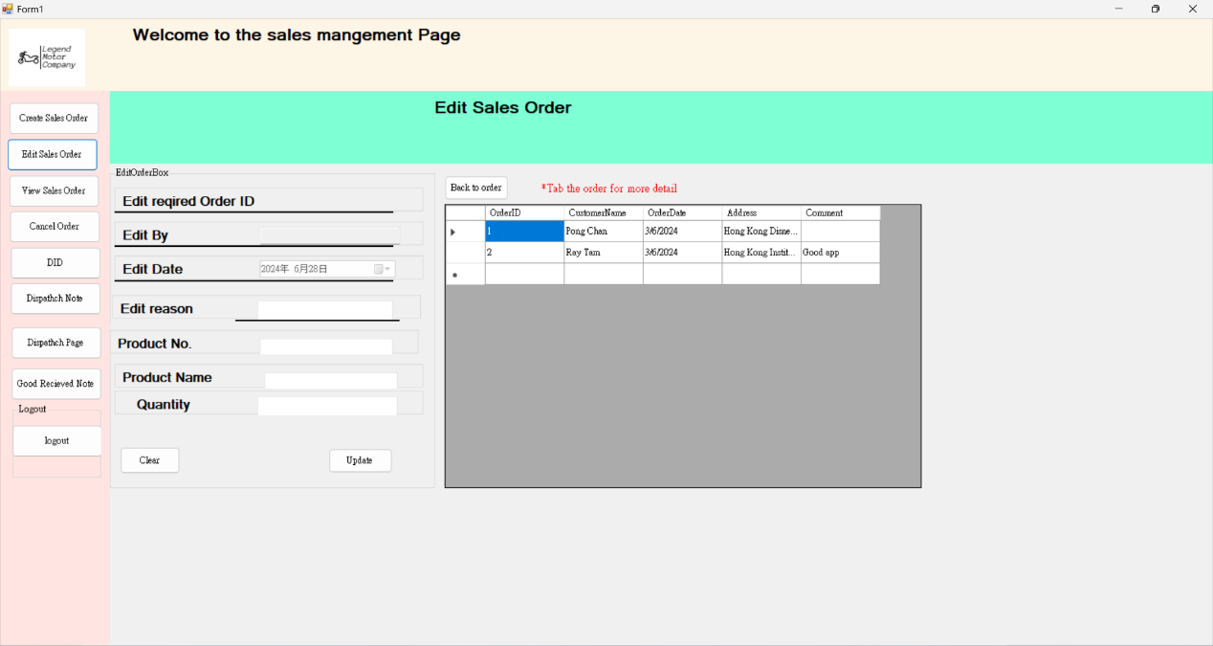

This page can change the order detail. The user can see each order and the order detail. The sales manager can change the ordered quantity after it changes it need to write why the sales manager needs to change it.

* CreateSalesOrderPage

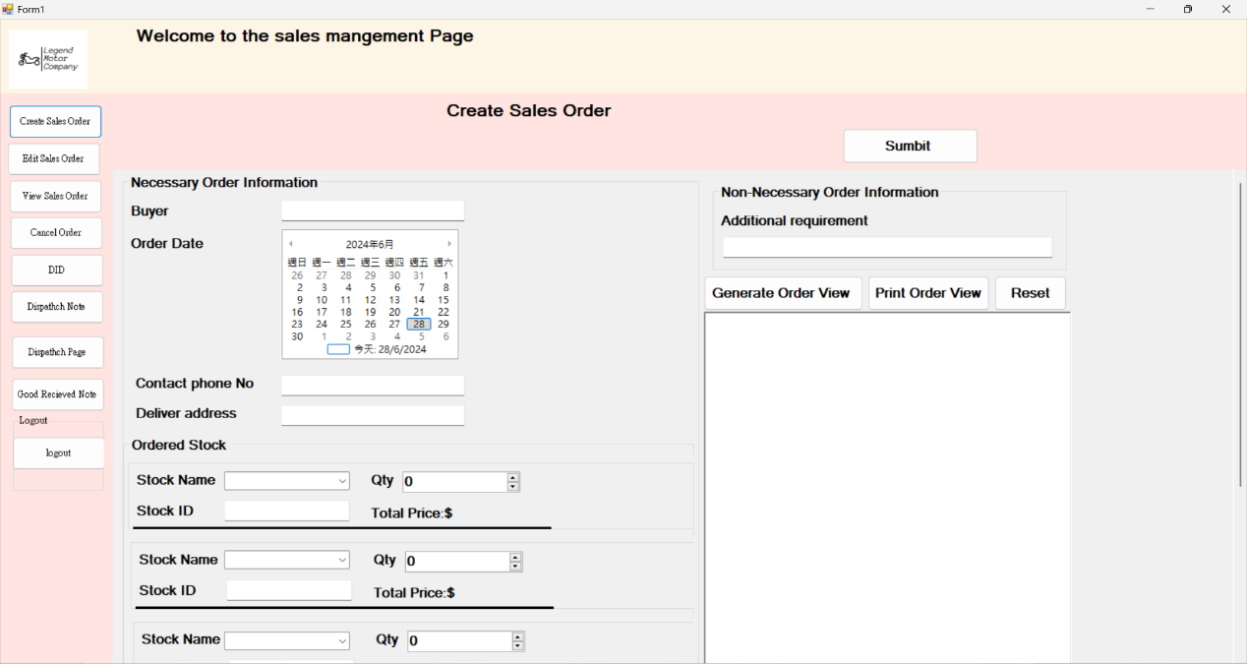

The sales manager can place an order. Whenever place an order it needs to enter the recipient's name, phone number and delivery address

* ViewSale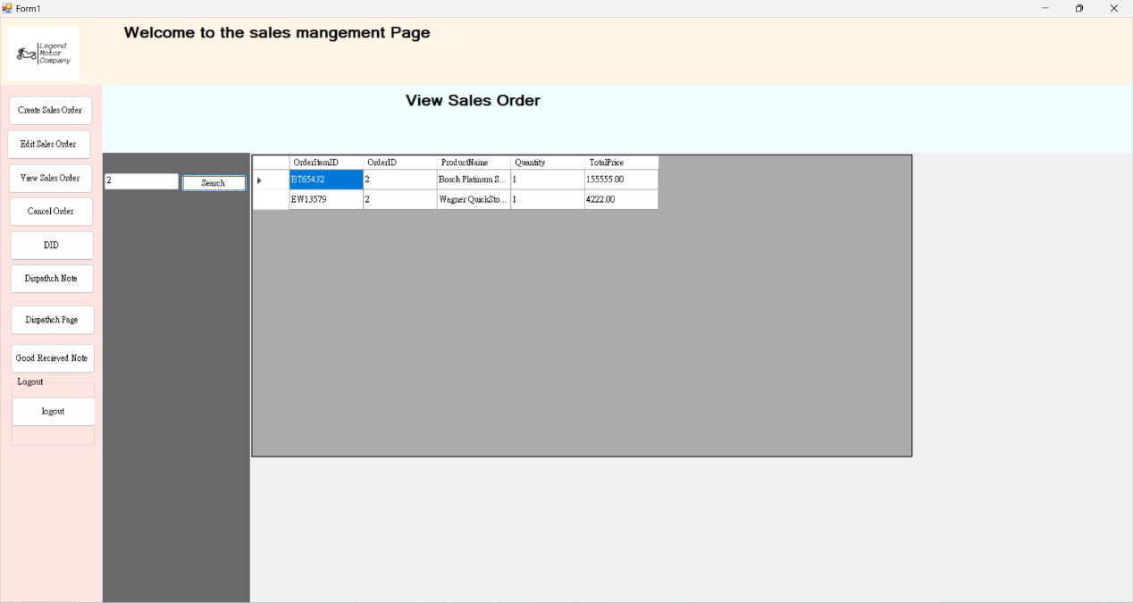

This page is for the sales manager to search the order detail.

* Update_DID

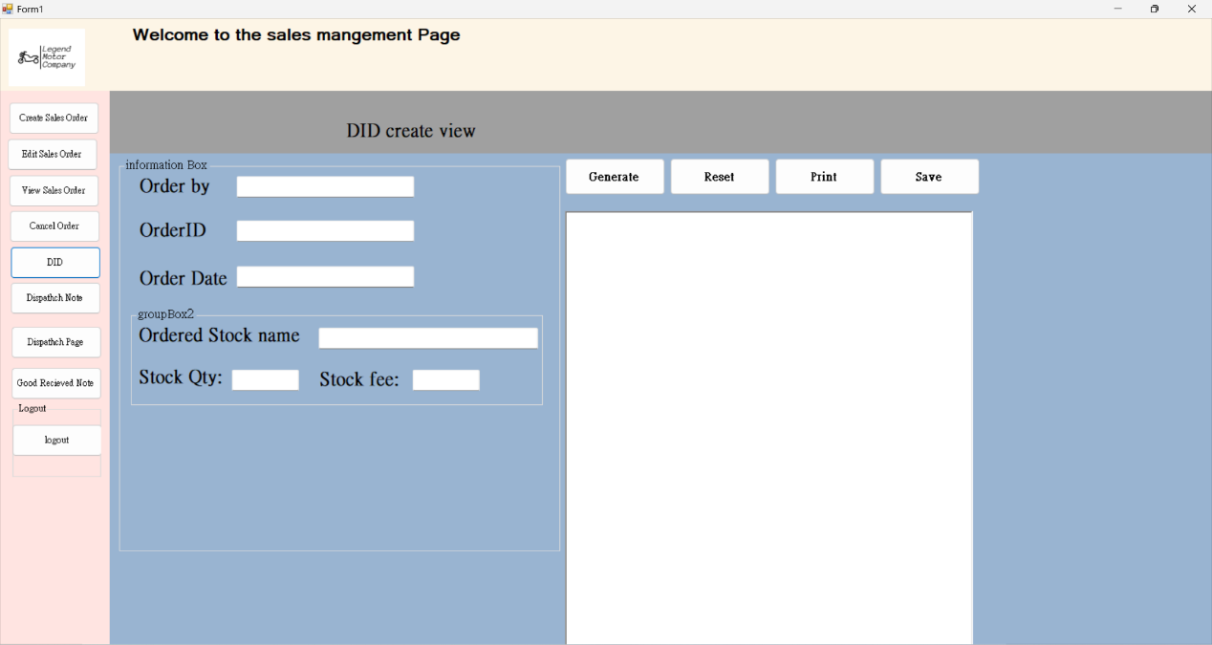

* Cancel order

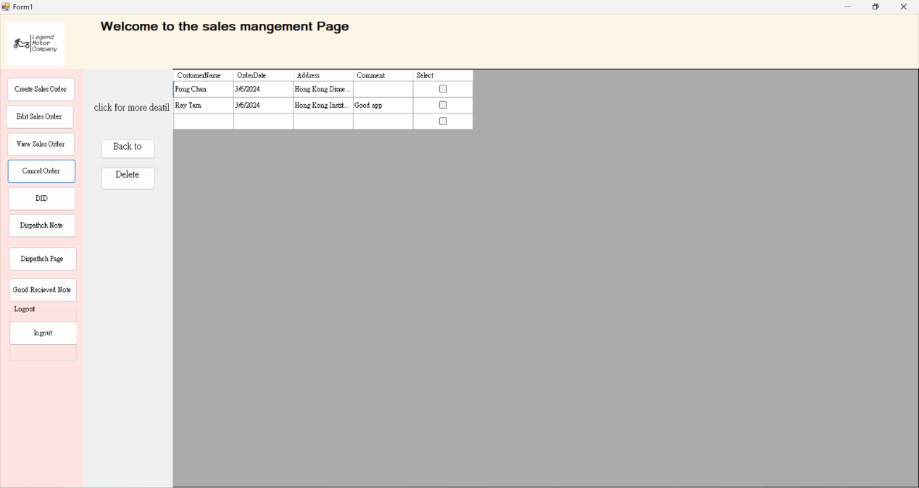

This page is for the sales manager to cancel their order when he places the order within 3 days.

-Stock Record system

* New_StockRecord_Meun

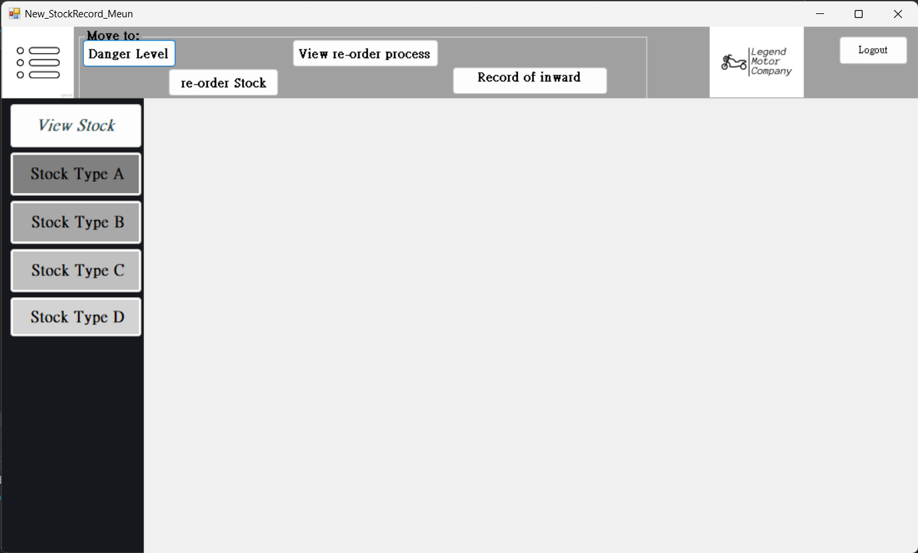

Description:

The stock recording menu will show up after the user has login as a Stock Record Staff account. And there are four main function in the menu page. In the top left corner is three button which is user for going to other functional menu. Danger level, re-order process and view re-order process three main functions. And under the left corner is the view current stock record button, if the user click it the recording will show in the center of the menu and this is not a move to action, the user can still see the logout, Move to button and other stock button. Finally there is a logout button, if the user click then screen will go back to the login page.

* ReOrderPage

Description:

Here is the re-order page. If the user have clicked the re-order stock button, then this page will be show up. And in the center of the page, there is a several group box in the center of the page. Each group box are contain the re-order stock input box and those input boxes are necessary to input the correct data unless all the input box in the group box is empty. If the user inserted all required data in the re-order input box, there is a submit re-order request button in the top right corner for user to submit the re-order request. And there is two button in the left hand side which is back to main page and View re-order process. The former is back to the main menu and the View re-order process button will lend the user to the View re-order process page.

* Danger Level page:

Description:

There are two side of the screen and each group box is contain different function and insertion requirement. As the top of the screen, there is the update current stock danger level group box in the left hand side of the screen. The user must insert a correct exist stock ID as(A0001), previous danger level(120), new danger level, updated date and updated by five input box. And then click the update button to update the current stock danger level, if the input is wrong or empty, it will show a error message.

For the right hand side of the screen is the insert new stock danger level, if there are any new stock is going to sell and evaluated the danger level. The user can use the right group box to insert the required data of the new stock and all input box are required to be inserted. if the user inserted all the data into the input box correctly, then click the add button to insert the new stock and the danger level into the database

* View re-order process

Description:

Here is the viewing of the re-order process page, there are three small screen in the center of the page, which is processing, delivering and completed. each screen will only show there own data which be alone in there topic. And there will show up there own re-order ID, ordered stock ID, stock name, re-order quantity, total price, address, re-order Date and re-order status. If the user want to view more information of the re-order. There is a rollers which is user for view order the column of the order in the screen.

And there is a searching input box and search button in the left hand side. Those are user for the user search the re-order.

And the lower left hand side is the button for go back to the main menu

* StockA_record

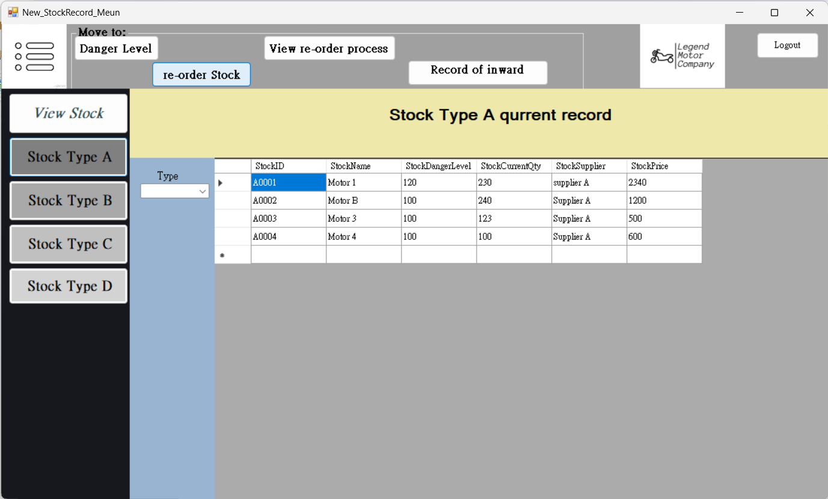

Description:

Here is the View current stock user interface, if the user double click the button of View order then there will be show up four Stock type button. Each button will show different stock current record in the database. For example here is the user interface of Stock type 1 and there will be only show the Stock by A and 1 current stock, and there is a Type input box. It is user for the user to find other stock type in here.

* StockB_record

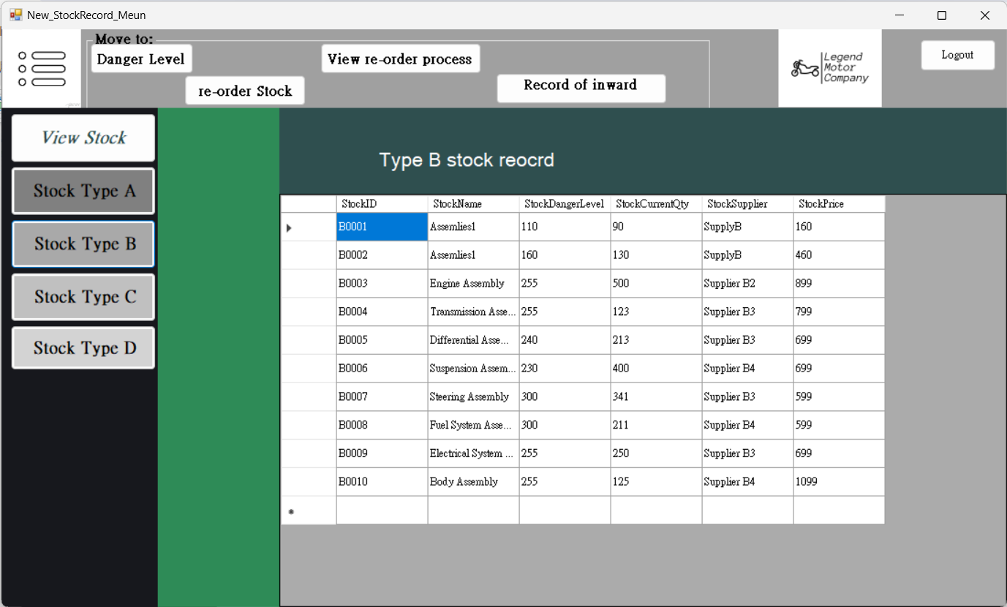

Description:

Here is the view of the stock B, if the user clicked the stock type 2 button and there will show all the column in the database such as ProductNo, stock name, part name, current quantity danger level and stock price

* StockC_record

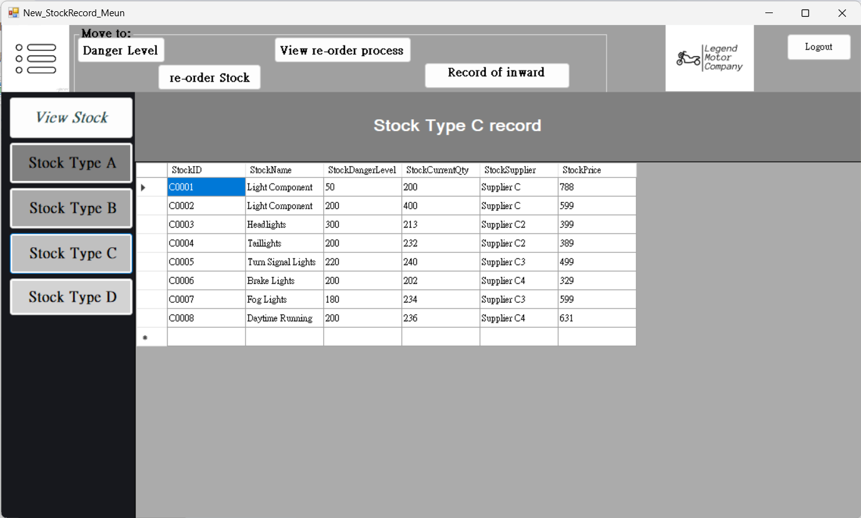

Description:

Here is the view of the stock C, if the user clicked the stock type 3 button and there will show all the column in the database such as Stock ID, Stock Name, Stock danger level, stock current qty, supplier and prices

* StockD_record

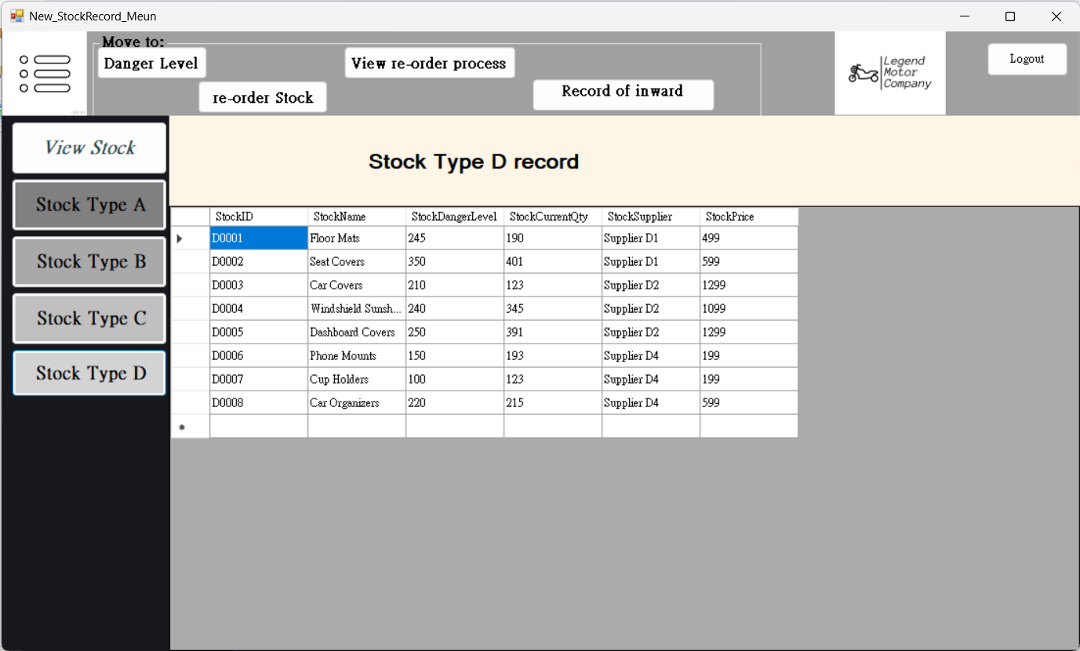

Description:

Here is the view of the stock D, if the user clicked the stock type 4 button and there will show all the column in the database such as Stock ID, Stock Name, Stock danger level, stock current qty, supplier and prices

* Record_of_inward_goods

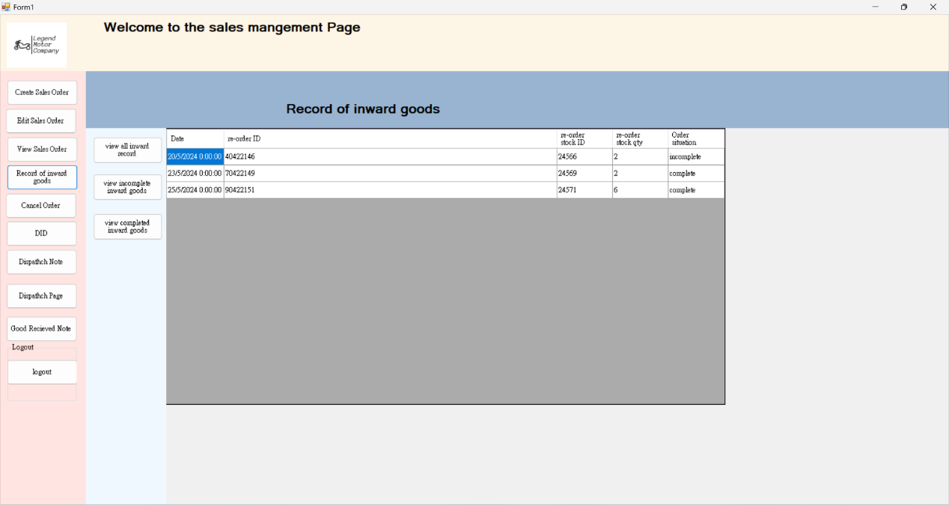

# · All test cases and test data

Login system test case:

|  |  |
| --- | --- |
| Test Case ID | TC-001 |
| Objective | To login with correct password and username. |
| Test Case Description | The user login his/her account with correct password and username |
| Precondition |  |
| Test Steps | 1.Input username  2.Input password |
| Test data | Username: Ben9999  Password: Ab10203040 |
| Expected outcome | Login successfully and display main page |
| Actaul outcome | Login successfully and display main page |

|  |  |
| --- | --- |
| Test Case ID | TC-002 |
| Objective | To verify that the system denies access when an incorrect username or password is provided.. |
| Test Case Description | The user attempts to log in with an incorrect username or password. |
| Precondition | None |
| Test Steps | 1.Input username:abc5678@gmail.com (incorrect username)  2.Input password: WrongPassword (incorrect password)  3.Click the login button. |
| Test data | Username: abc5678@gmail.com  Password: WrongPassword |
| Expected outcome | The system should display an error message indicating that the username or password is incorrect and deny access to the user. |
| Platform | Window10 |
| Test Case ID | TC-003 |
| Objective | To verify that the "Forgot Password" button on the login page functions correctly. |
| Test Case Description | A user clicks the "Forgot Password" button on the login page. |
| Precondition | The user is on the login page. |
| Test Steps | 1. Click the "Forgot Password" button on the login page. 2. Enter user email address. 3. Enter old password 4. Enter new password 5. Confirm new password 6. Click reset button |
| Test data | Current Password: Ab10203040  New Password: NewPassword123 |
| Expected outcome | The system should successfully reset the user's password and display a confirmation message. |
| Actaul outcome | The user's password has been reset, and the system displays a confirmation message "Password changed successfully. |
| Platform | Window10 |

Account management system test case:

|  |  |
| --- | --- |
| Test Case ID | TC-004 |
| Objective | To verify that the system allows an administrator to change user password. |
| Test Case Description | The admin attempts to change user password. |
| Precondition | Admin is logged in to the system. |
| Test Steps | 1. Navigate to the "Users" or "Manage Users" section. 2. Select the change password button. 3. Select the user you want to change the password. 4. Enter new password 5. Enter the new password again. |
| Test data | Current Password: ABC123456  New Password: NewPassword123 |
| Expected outcome | The system should successfully update the user's password and display a confirmation message. |
| Actaul outcome | The user's password is updated, and the system displays a confirmation message "Password changed successfully. |
| Test Case ID | TC-005 |
| Objective | To verify that the system allows an administrator to add a new user. |
| Test Case Description | An administrator attempts to add a new user to the system. |
| Precondition | Admin is logged in to the system. |
| Test Steps | 1. Navigate to the "Users" or "Manage Users" section. 2. Click the "Add User" button. 3. Enter the following user details   Username: Tam2123456  Email: Tam2123456@lmc.com  Password: ABC123456  Confirm Password: ABC123456  Job title: Staff  4. Click the "Create" button.. |
| Test data | Current Password: ABC123456  New Password: NewPassword123 |
| Expected outcome | The system should successfully update the user's password and display a confirmation message. |
| Actaul outcome | The user's password is updated, and the system displays a confirmation message "Password changed successfully. |
| Remark | Success |

|  |  |
| --- | --- |
| Test Case ID | TC-006 |
| Objective | To verify that the system allows a sales representative to create a new sales order. |
| Test Case Description | A sales representative attempts to create a new sales order.. |
| Precondition | User is logged in as a sales representative.  Products/services are available in the system. |
| Test Steps | 1. Navigate to the "Sales" or "Orders" section of the system. 2. Click the "Create Sales Order" button. 3. Enter the buyer information ,Name, Order date, Deliver address. 4. Add the desired products or services to the order, specifying the quantity and any applicable discounts or taxes. 5. Review the order details, including the total amount. 6. Click the "Submit " button to create the new sales order. |
| Test data | Buyer: ABC Corporation  Products: Duralast Disc Brake Rotor 54048 |
| Expected outcome | The system should successfully create the new sales order with the provided details. |
| Actaul outcome | The new sales order is created with the specified customer, products, and order details. The system displays a confirmation message created successfully. |
| Remark | Success |
| Test Case ID | TC-007 |
| Objective | To verify that the system prevents the creation of a new sales order when the delivery address is not provided. |
| Test Case Description | A sales representative attempts to create a new sales order without entering the delivery address. |
| Precondition | User is logged in as a sales representative.  Products/services are available in the system. |
| Test Steps | 1. Click the "Create Sales Order" button. 2. Add the desired products or services to the order, specifying the quantity and any applicable discounts or taxes. 3. Do not enter the delivery address or name for the order. 4. Click the "Submit " button to create the new sales order. |
| Test data | Buyer:  Products: Duralast Disc Brake Rotor 54048 |
| Expected outcome | 1.The system should not allow the creation of the sales order without the delivery address.  2.The system should display an error message or validation warning indicating that the delivery address is required. |
| Actaul outcome | The system displays an error message: "Delivery address is required to create a new sales order. Please provide the delivery address and try again." |
|  |  |
| Test Case ID | TC-008 |
| Objective | To verify that the system allows a sales representative to edit an existing sales order. |
| Test Case Description | A sales representative attempts to edit an existing sales order. |
| Precondition | User is logged in as a sales representative.  At least one existing sales order is available in the system. |
| Test Steps | 1. Click the "Edit Sales Order" button at menu page. 2. Locate the sales order that needs to be edited. 3. Tap the order to get more detail 4. Update the order details what you want, such as OrderItemID or ProductName or Quantity. 5. Review the updated order details. 6. Click the "Update " button to apply the changes. |
| Test data | OrderID:2  Products: Bosch Platinum Spark Plug Set 9666 |
| Expected outcome | 1. The system should successfully update the order details based on the changes made by the sales representative.  2. The updated sales order should be saved in the system, and the changes should be reflected in the sales order list or dashboard. |
| Actaul outcome | As expected |
| Remark | Success |

|  |  |
| --- | --- |
| Test Case ID | TC-009 |
| Objective | To verify that the system allows a sales representative to search for a specific sales order by order ID. |
| Test Case Description | A sales representative attempts to find a sales order by searching for the order ID. |
| Precondition | User is logged in as a sales representative.  Multiple sales orders are available in the system. |
| Test Steps | 1.Click the "View Sales Order" button at menu page.  2.Enter the order ID in the search field.  3.Click the "Search"button. |
| Test data | Buyer:  Products: Duralast Disc Brake Rotor 54048 |
| Expected outcome | 1.The system should display the details of the sales order with the matching order ID.  2.The system should not display any other sales orders that do not match the search criteria. |
| Actaul outcome | As expected |
| Remark | Success |

|  |  |
| --- | --- |
| Test Case ID | TC-0010 |
| Objective | To verify that the system allows a sales representative to edit an existing sales order. |
| Test Case Description | A sales representative attempts to edit an existing sales order. |
| Precondition | User is logged in as a sales representative.  At least one existing sales order is available in the system. |
| Test Steps | 1. Click the "Edit Sales Order" button at menu page. 2. Locate the sales order that needs to be edited. 3. Tap the order to get more detail 4. Update the order details what you want, such as OrderItemID or ProductName or Quantity. 5. Review the updated order details. 6. Click the "Update " button to apply the changes. |
| Test data | OrderID:2  Products: Bosch Platinum Spark Plug Set 9666 |
| Expected outcome | 1. The system should successfully update the order details based on the changes made by the sales representative.  2. The updated sales order should be saved in the system, and the changes should be reflected in the sales order list or dashboard. |
| Actaul outcome | The system updates the order details as specified, and the changes are saved successfully. A confirmation message “ updated successfully" is displayed. |

Stock Record system test case:

|  |  |
| --- | --- |
| Test Case ID | TC_SR0001 |
| Objective | Test update danger level for the current exist stock |
| Test Case Description | Test Update current Stock danger Level |
| Precondition | 1. Current stock is exist in the database 2. User login the stock record page |
| Test Steps | 1. Open Stock record page and select danger level button 2. Insert Correct update required stock ID, previous danger level, new stock danger level, update date and updated by 3. Push the update button |
| Test data | A0001(StockID) 120(previous danger level) 150(new stock danger level), 26-6-2024(updated date default system date) Tam213456 (user name) |
| Expected outcome | Show Updated success message bx and the database is updated |
| Actaul outcome | Stock table updated  Test success |
| Platform | Window10 |
| Test Case ID | TC_SR0002 |
| Objective | Test update danger level for the current exist stock by insert wrong data |
| Test Case Description | Test Update current Stock danger Level checking |
| Precondition | 1. Current stock is exist in the database 2. User login the stock record page |
| Test Steps | 1. Open Stock record page and select danger level button 2. Insert Correct update required stock ID, previous danger level, new stock danger level, update date and updated by 3. Push the update button |
| Test data | F0001(StockID) 120(previous danger level) 150(new stock danger level), 26-6-2024(updated date default system date) Tam213456 (user name) |
| Expected outcome | Show Updated does not success message |
| Actaul outcome | Error message  Outcome: not success |
| Platform | Window10 |

|  |  |
| --- | --- |
| Test Case ID | TC_SR0003 |
| Objective | Test insert new stock in database and update database |
| Test Case Description | Test data insertion is correct or not in database |
| Precondition | 1. Already have correct data of new stock data and know the danger level |
| Test Steps | 1. Open Stock record page and click the danger level button 2. Insert data in the Add new stock’s danger level input box 3. Insert data into all input box 4. Push Add button |
| Test data | F0001(StockID) Car Part F1 (New Stock Name) 150 (new danger level) 599 (price) 26-6-2024(updated date default system date) Tam213456 (user name) |
| Expected outcome | Show insertion success message |
| Actaul outcome | Show insertion success message |
| Platform | Window10 |

|  |  |
| --- | --- |
| Test Case ID | TC_SR0004 |
| Objective | Test data checking in the add new stock input box |
| Test Case Description | Try to insert incorrect data in the input box |
| Precondition | the system can detect the wrong data and the insertion should be English. |
| Test Steps | 1. Open Stock record page and click the danger level button 2. Insert data in the Add new stock’s danger level input box 3. Insert wrong data into the input box 4. Push Add button 5. Wrong message show |
| Test data | F0001(StockID) Car Part F1 (New Stock Name) ABC (new danger level) ABC (price) 26-6-2024(updated date default system date) Tam213456 (user name) |
| Expected outcome | Show insertion error message  Database will not insert any data |
| Actaul outcome | Show insertion error message |
| Platform | Window10 |

|  |  |
| --- | --- |
| Test Case ID | TC_SR0005 |
| Objective | Test the viewing of the re-order process |
| Test Case Description | Test the da ta will show the correct data in the database or not |
| Precondition | Current data already have re-ordered order as processing, delivering and completed order |
| Test Steps | 1. Login into the stock record page and select View order button 2. Enter the order ID to search for the order 3. Check the order data will show on the screen or not |
| Test data | Order ID: 1 |
| Expected outcome | Found the correct Order Id and the information of the order |
| Actaul outcome | The order Found |
| Platform | Window10 |

|  |  |
| --- | --- |
| Test Case ID | TC_SR0006 |
| Objective | View current stuck in different type |
| Test Case Description | Test the user can view the stock record in the database or not |
| Precondition | There are already recorded all type of stock in the database |
| Test Steps | 1. Login into the stock record click the view Stock button 2. Click the required the stock to view the record 3. Click stock type A and click the Type button to select stock |
| Test data | Type: A selected |
| Expected outcome | Find expected the stock type in the searching |
| Actaul outcome | Expected stock type is found |
| Platform | Window10 |

|  |  |
| --- | --- |
| Test Case ID | TC_SR0007 |
| Objective | Test the wrong input of the re-order stock insertion |
| Test Case Description | Test the re-order process by inserting wrong input of the re-order |
| Precondition | Insert the newer-order stock is not repeat |
| Test Steps | 1. Login into the stock record click the view Stock button 2. Click the re-order stock button 3. Insert wrong data into the input box 4. Click submit re-order button |
| Test data | Stock name(123), stock ID (ABC), quantity (1) |
| Expected outcome |  |
| Actaul outcome |  |
| Platform | Window10 |

# · User Guide

Login user guide:

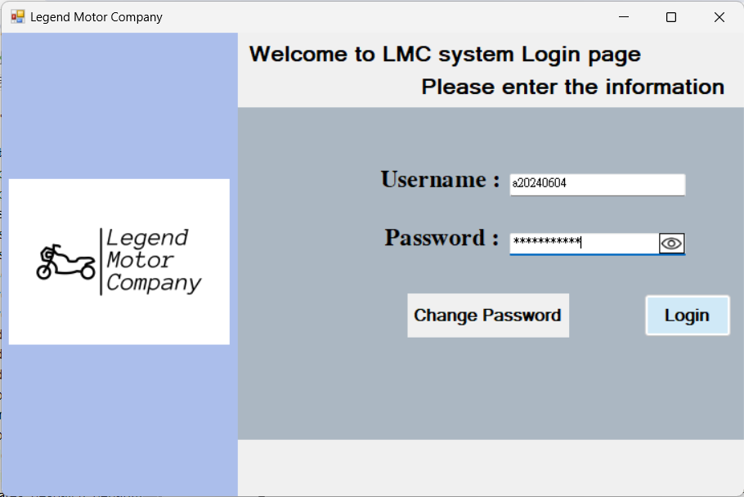

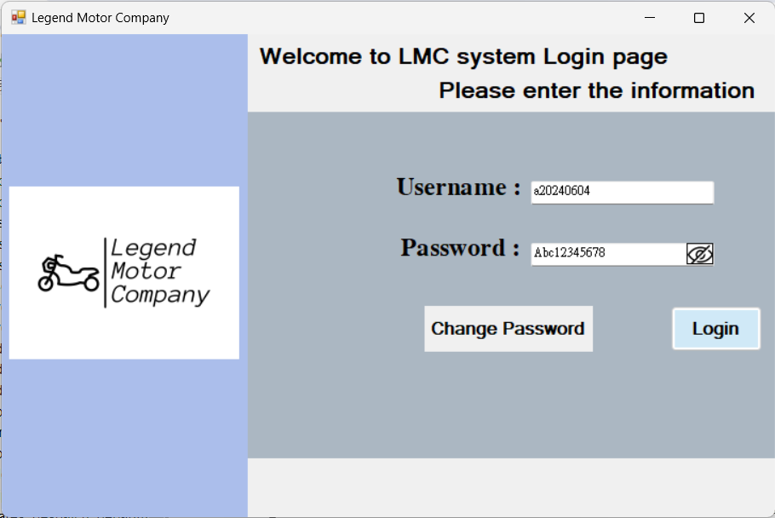

In this page it can help 3 different roles of the user to login and change their password. As you can see next to the password text box there is an eye. If the user clicks it the user can see watch they just enter in the text box it will not still look like the *. And the eye will be having a slash that means if the user clicks it will turn the password to *.

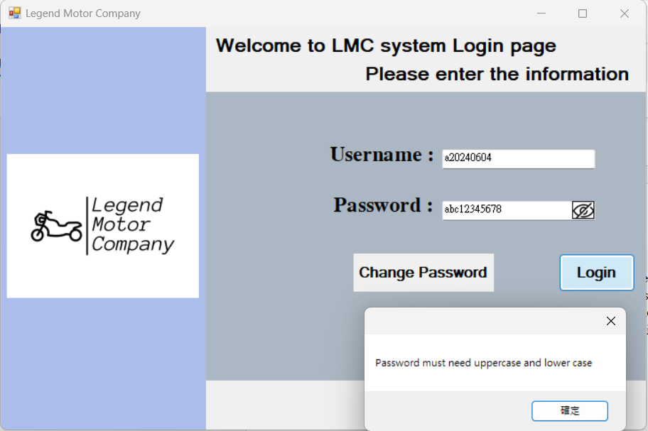

If the user clicks the Login button the system will validate the username and password correct or not. If there are some basic errors like the password without upper case and lower-case letter it will having the message box told user, the password must include it.

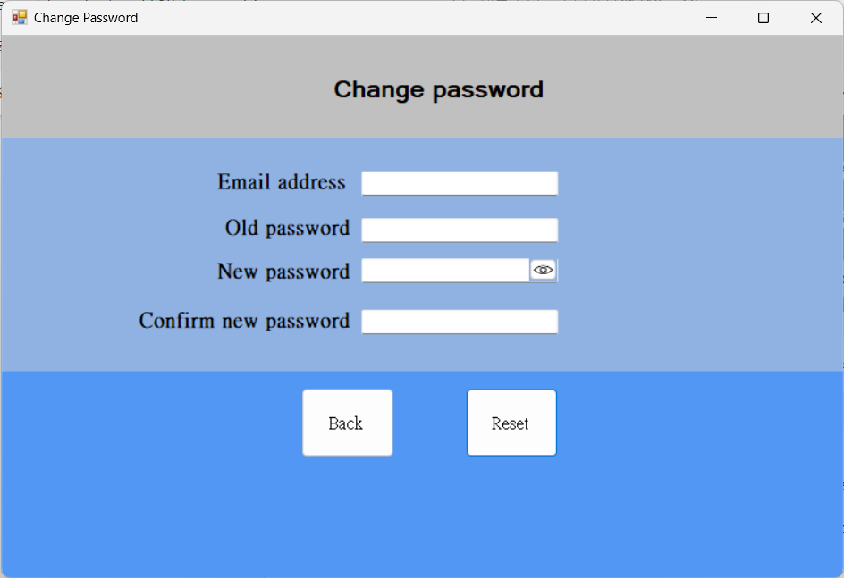

Under the password text box there is a "Change password" button, after the user clicks it, you will see a blue and gray form for the user to change their password. In this page the user needs to have their email address and the old password for change it to the new one. After the user enters all the information and click reset the new password will update to the database. Also, in this page also having the same function in the login page.

Admin user guide:

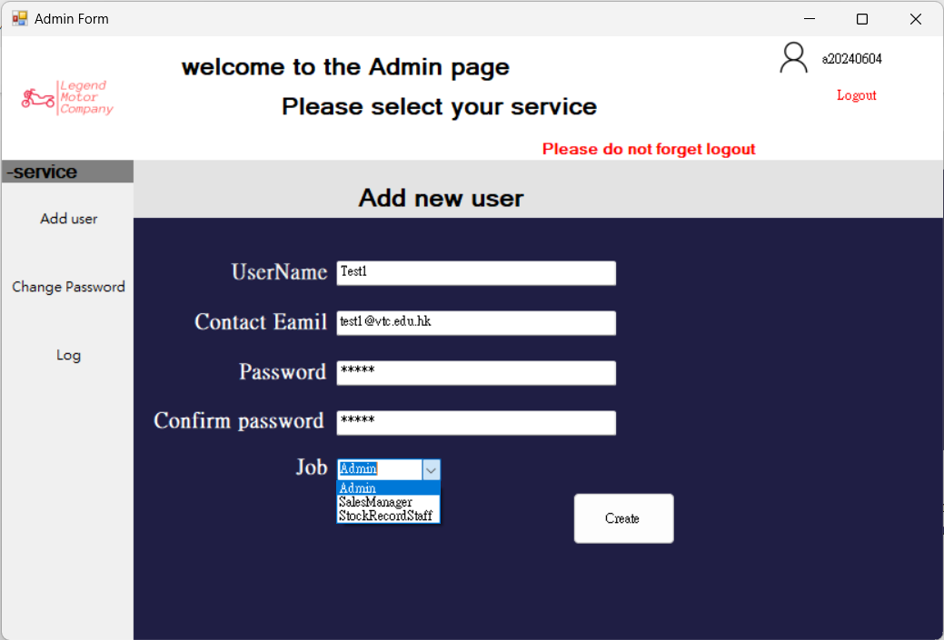

After the user clicks the add user button in the center of the screen it will come out a page like the picture. In the add user page you need to enter the new username, password, email address and the Job. In this page we can only create 3 types of the user administrator, sales manager and the stock record staff. After the user clicks the "Create" button it will check the email addresses are valid and the password are compliance.

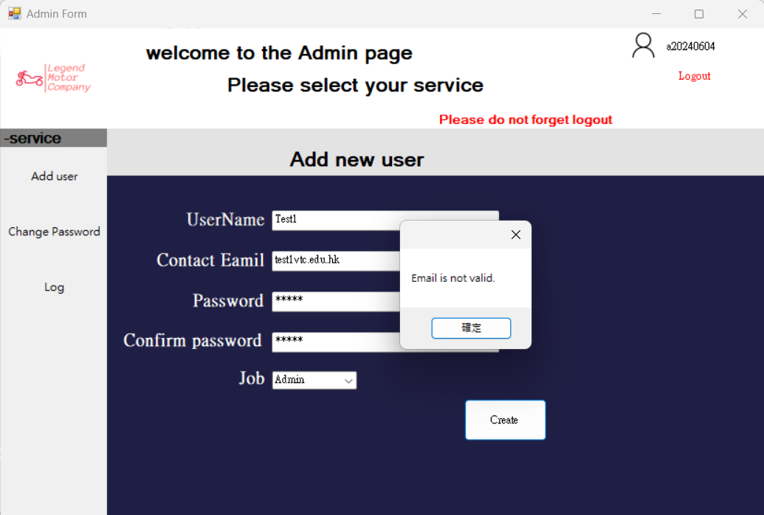

If the email address were not valided it will be having an message told user "Email is not valid".

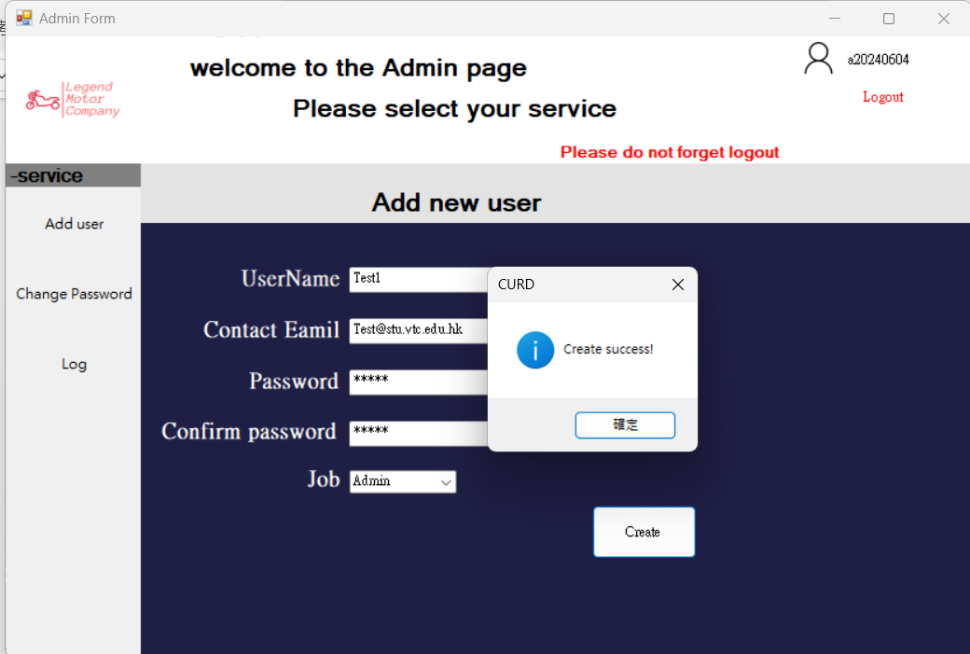

If all information were no problem, it will have a message box that told the user the new user was "Create success!" and the data will be uploaded to the database. After the user click "ok" all data in the screen will clear.

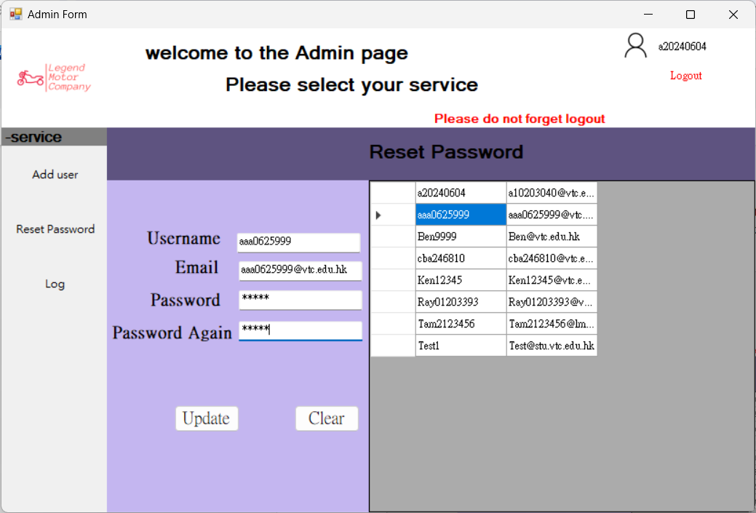

In the reset password page is for those who forget their password need admin to reset it. In the right-hand side, you can see it is the username and their email address, when user click the user who need to reset their password it will fill the username and email address.

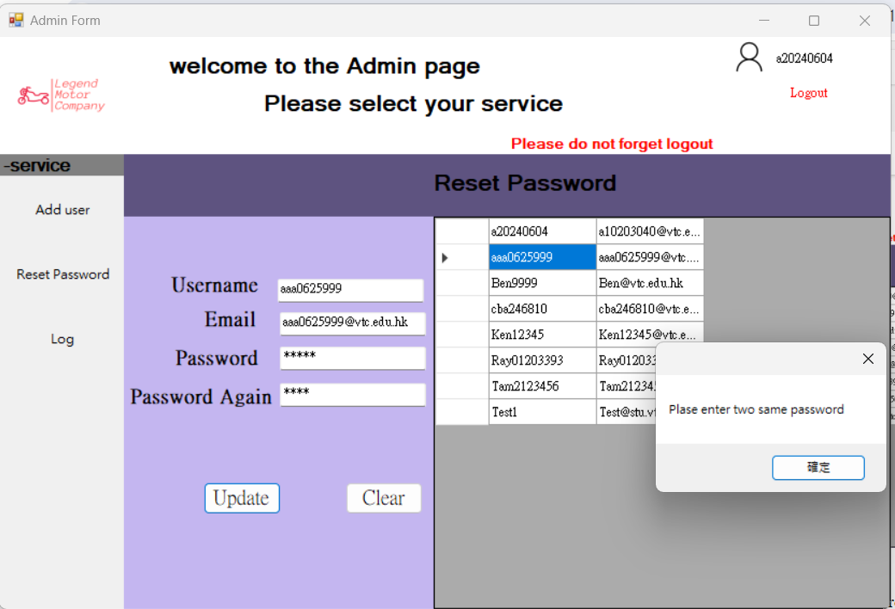

After the user fills all the columns and clicks the "Update" button, the system will check if the password is the same or not. If not, it will tell the user to enter two of the same passwords.

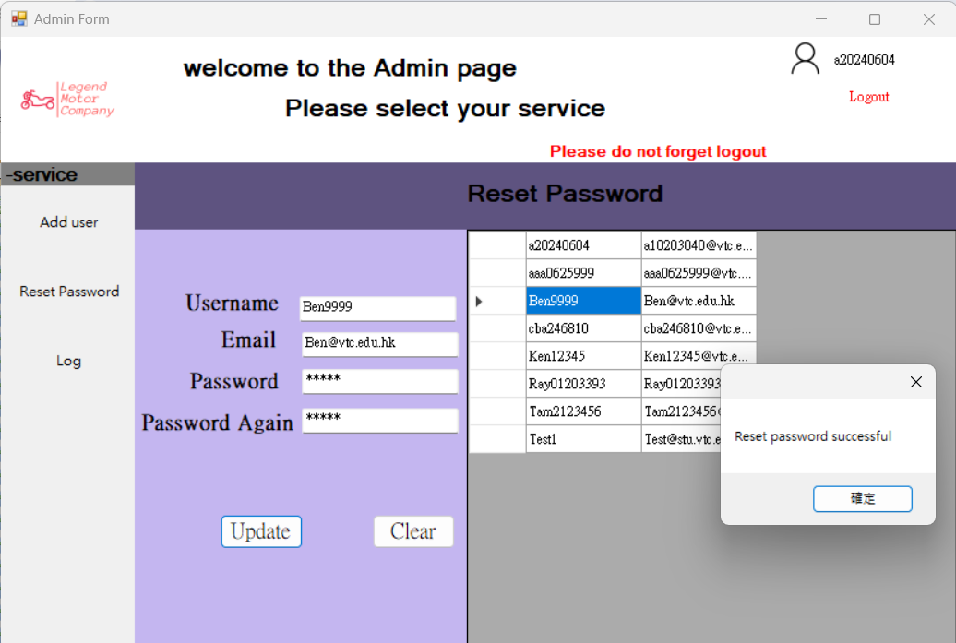If all data were no problem, it will tell user passwords were reset successfully.

In this page admin can see all changes on database and see what argument it does and when. It is useful for admin to maintain the database system. Users can sort each column.

Create Sales Order user guide:

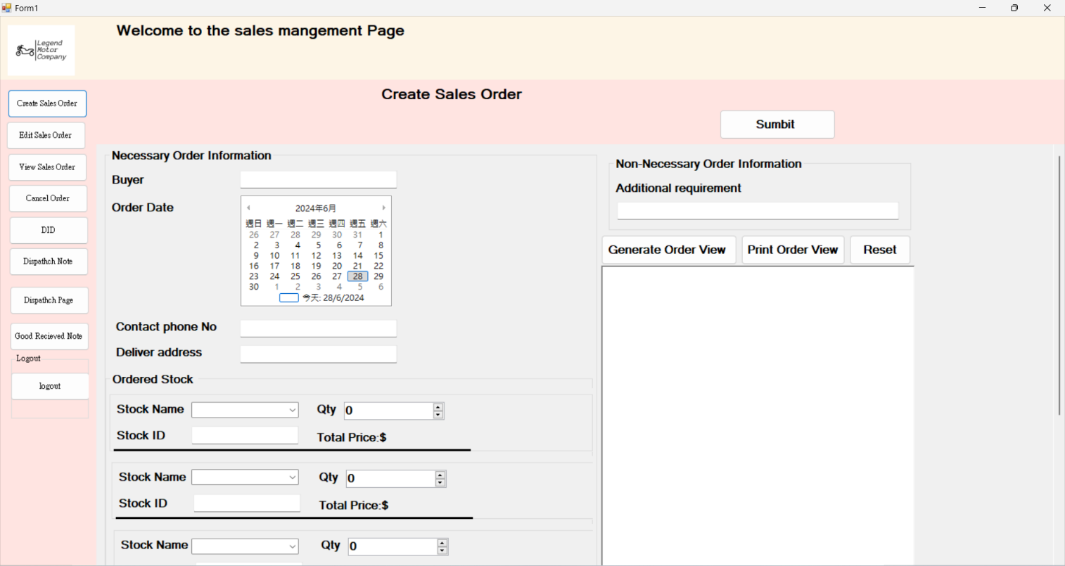

Step1: You need to enter the customer name n Buyer Blank.

Step2: Enter the customer contact phone number.

Step3: Enter the order delivery address.

Step4: You can select different product in the Ordered Stock area,the stock name is the drop down list of products,you can click the down arrow to select different products,then choose the quantity and it will show the product image and total price.Also, you can select more than one product in next order area.

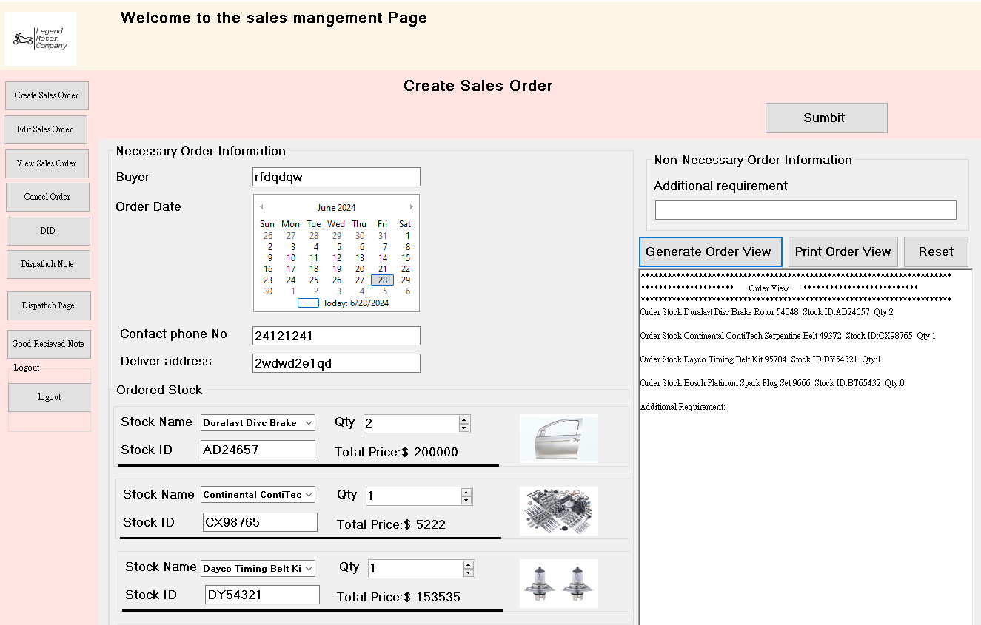

Step 6 : After selected the product you press the Genner button to see the all your selected product detail.

Step 7: Then you can press the Print Order View to see print view .

Step 8: You can also add some special requirements in Addtional requirement blank if you want .

Step9: Confirm all your order detail then press the Submit button on the top right.

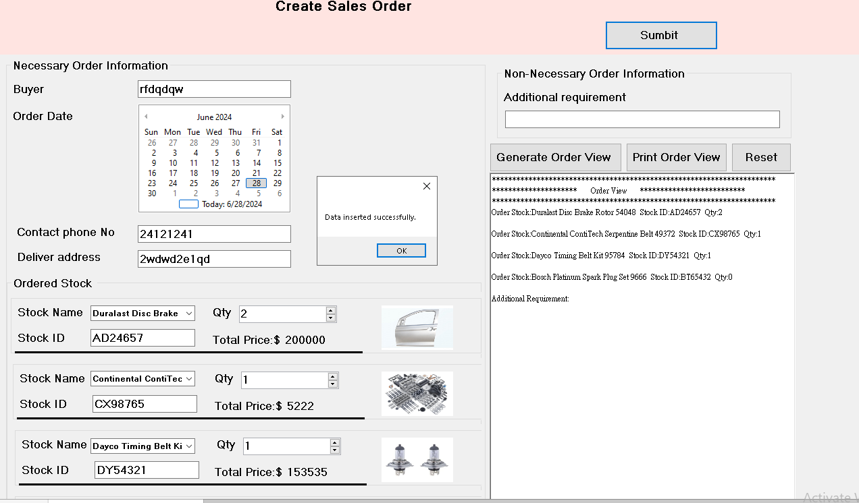

Finally you will see the Data inserted successfully message on the main page.

Edit Order User Guide

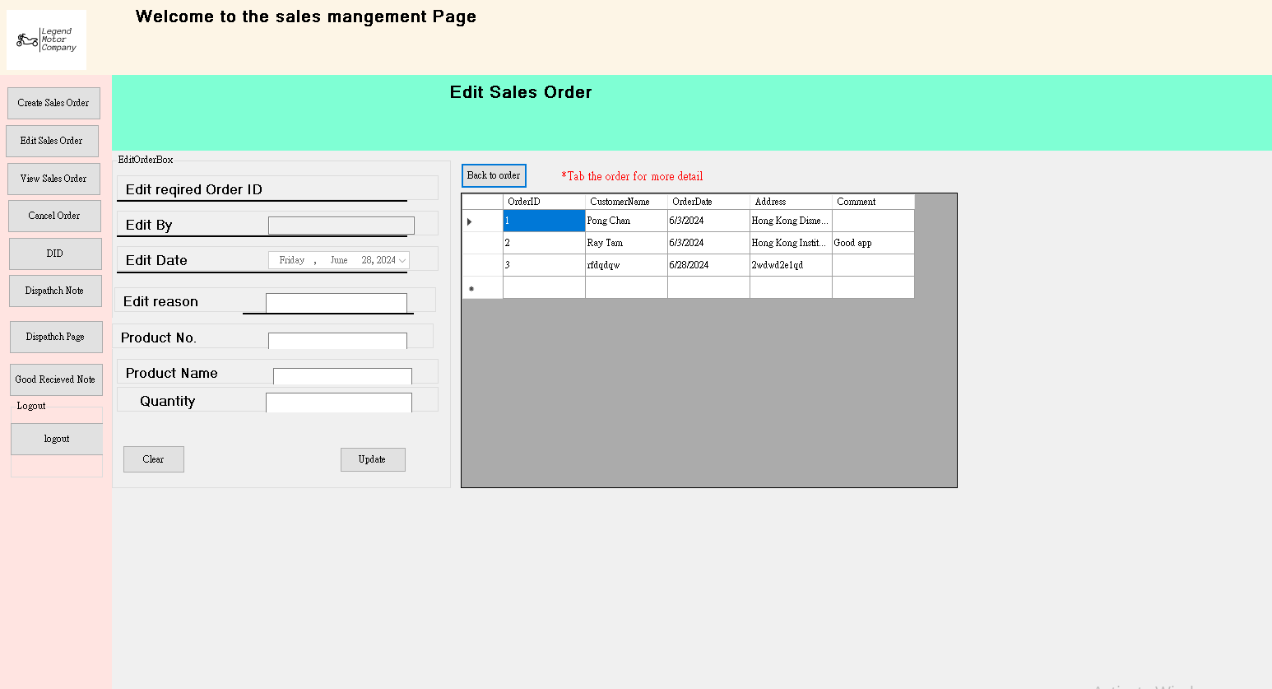

Step 1:Click the Edit Sales Order button.

Step 2: Follow the red text said, left click you mouse to see the order detail.

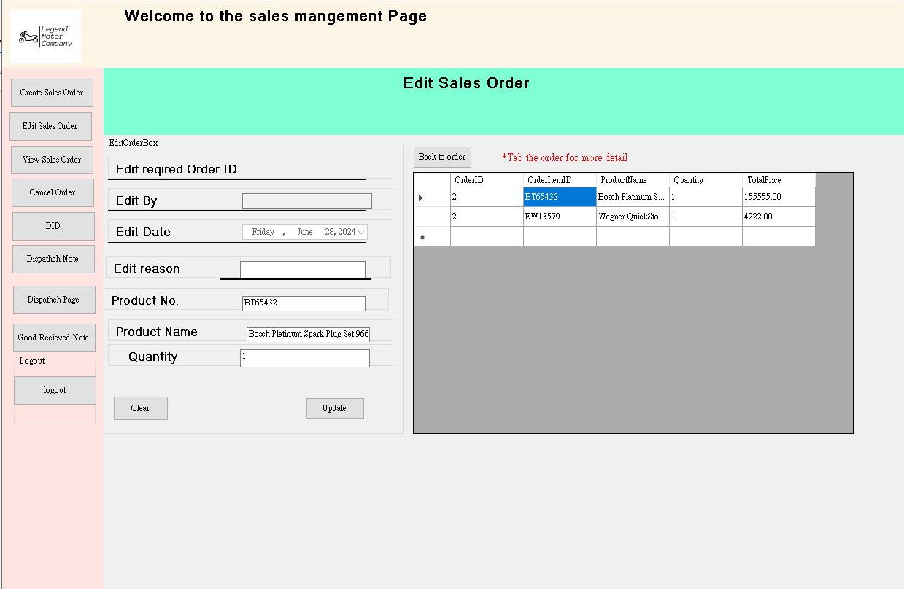

Step 3:After left click the customer, you can see the order detail of the customer.

Step 4 : left click the product which is you want to edit

Step 5:Enter the your name on Edit By and the Edit reason .

Step 6:You can select the product number ,product name or product quatity to edit.

Step 7 : Confirm your edit data the press Update button.

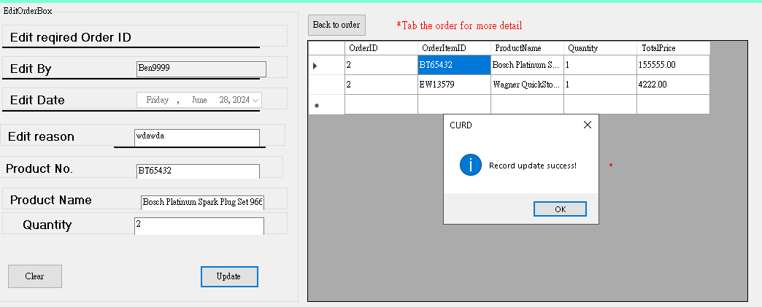

Finally, this is the Update successful page.It will show you Record update success message on the screen.

Search Order User Guide

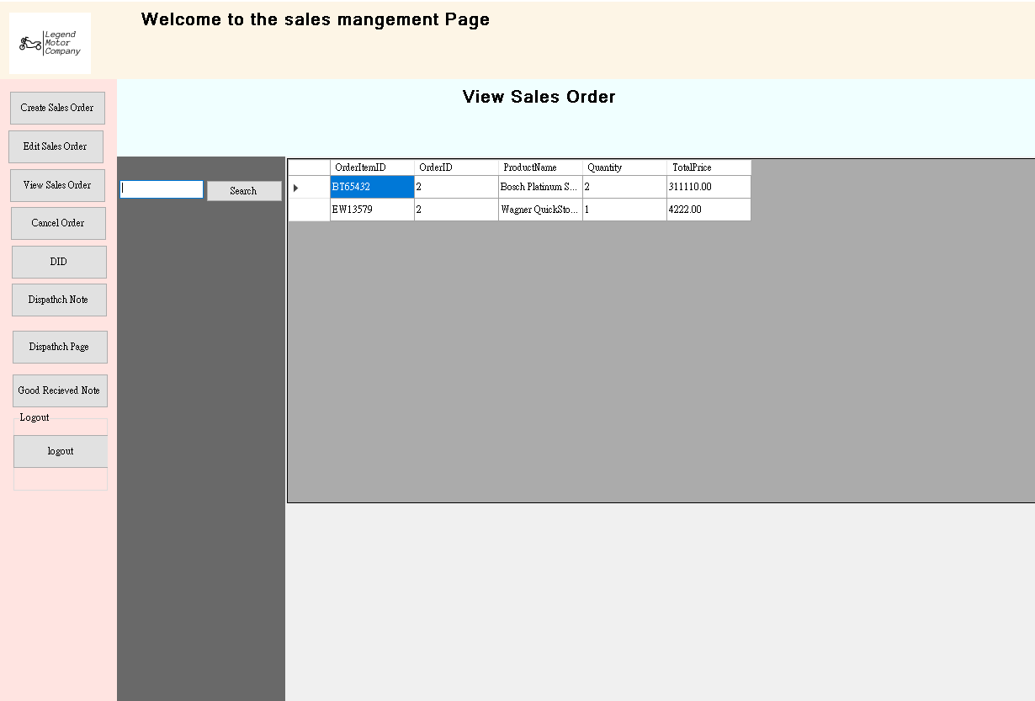

Step 1: Click the Search button to get in search order page

Step 2 : You can enter the Order ID then press the Search button to find the Order ID is match your requirements.

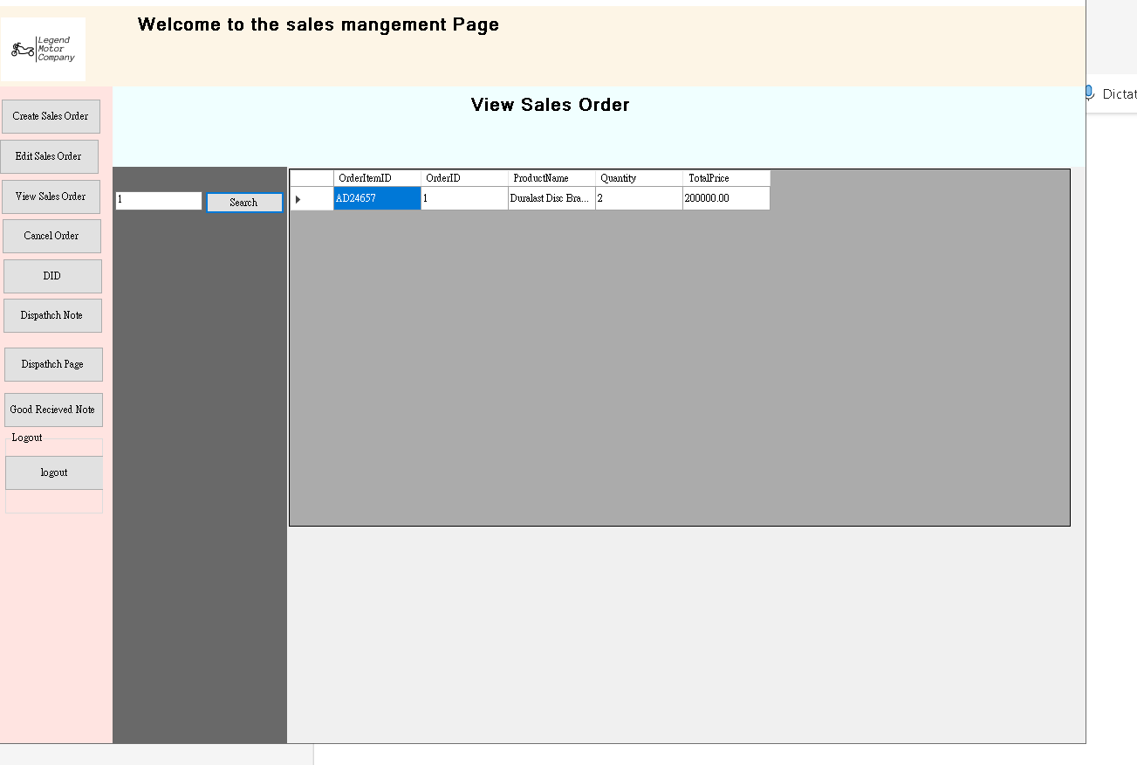

This the example after i want to search the Order ID is 1,then it will show me the Order ID is 1 ‘s order. Also it will show the order detail.

Delete Order User Guide

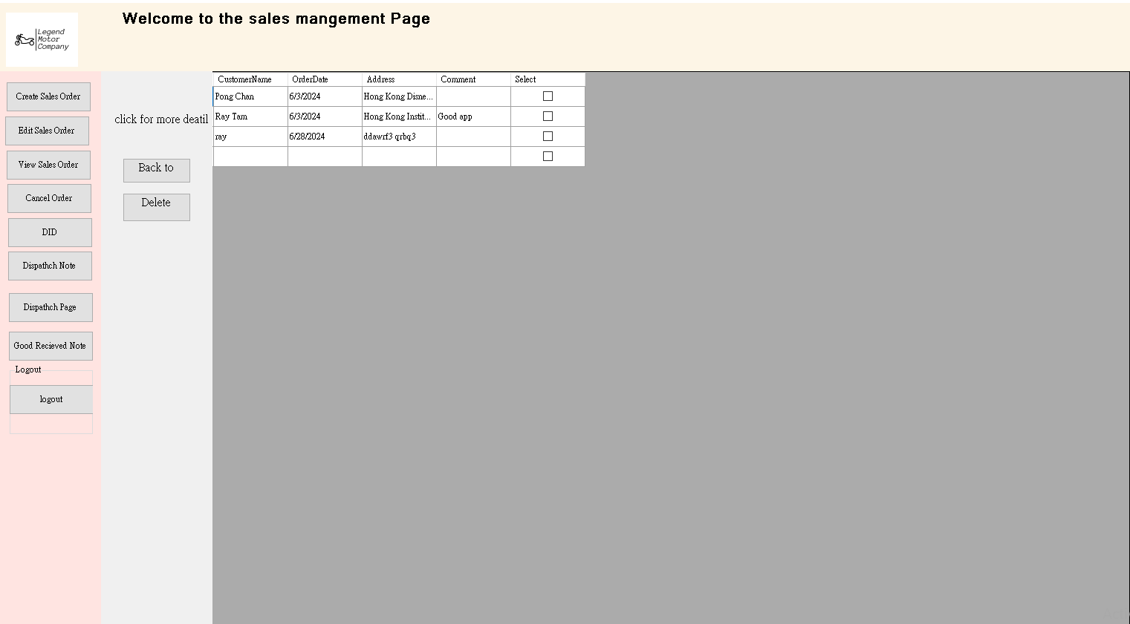

Step 1 : Click the Cancel Order button to get in this page.

Step 2: Select the order you want to cancel the tick the box.

Step 3: Press the delete button .

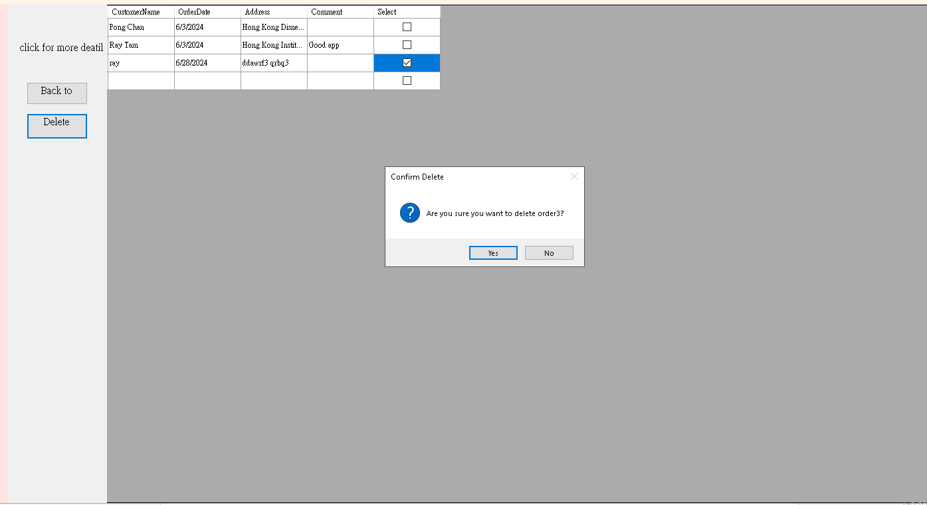

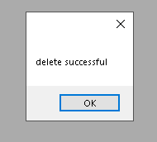

Step 4 :The system will ask you confirm to delete the order.

Step 5 : After you press yes , the system will show the delete successful message.

Dispatch Processing user guide:

On the dispatch page, sales managers can view the purchase order on the main page. When a purchase order has been chosen, the sales manager can generate a dispatch note after choosing the purchase order.

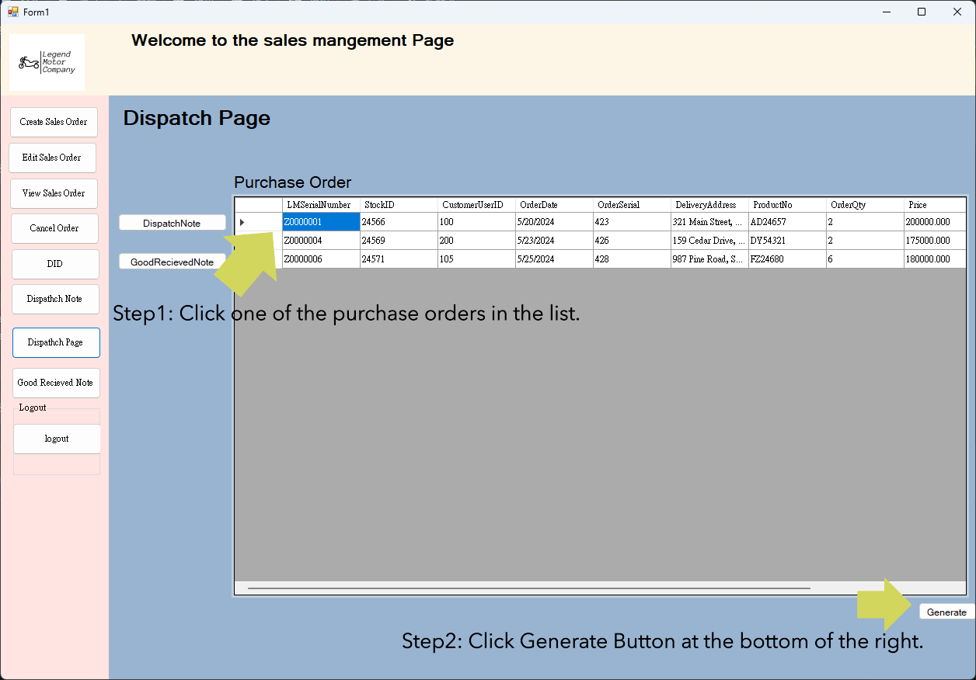

Step1: Click one of the purchase orders in the list.

Step2: Click Generate Button at the bottom of the right.

After choosing a purchase order, the Dispatch note page is for sales managers to confirm information about dispatching.

In this page, information of dispatching and the table of dispatch details are listed here, sales managers can edit the dispatch information such as dispatch staff, dispatch date and time, dispatch number and dispatch location

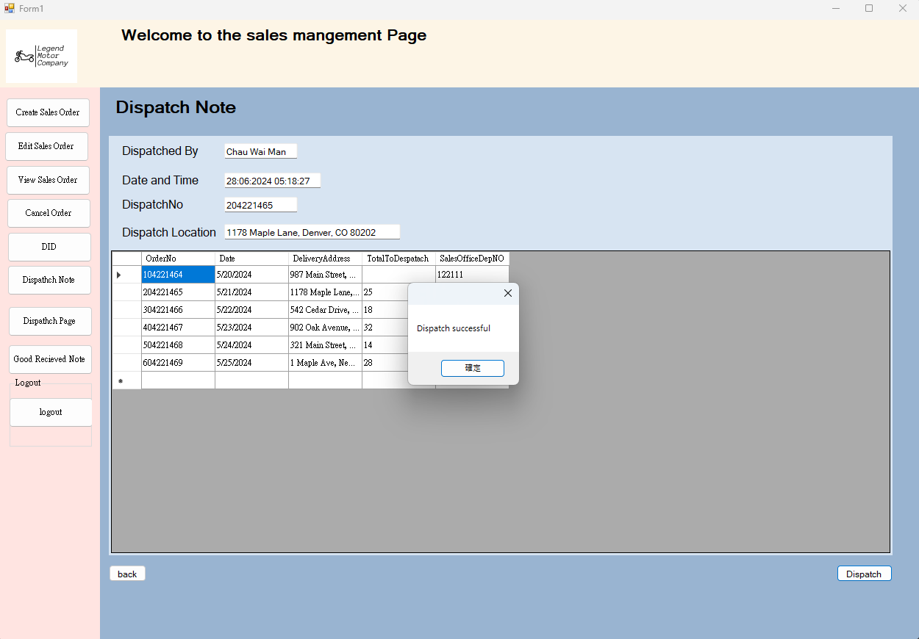After the information is confirmed to be correct, the sales manager can now dispatch the goods.

Good Received Note user guide  
In good received note page, sales managers can check the bills of received goods from supplier and send copies to 4 department.  
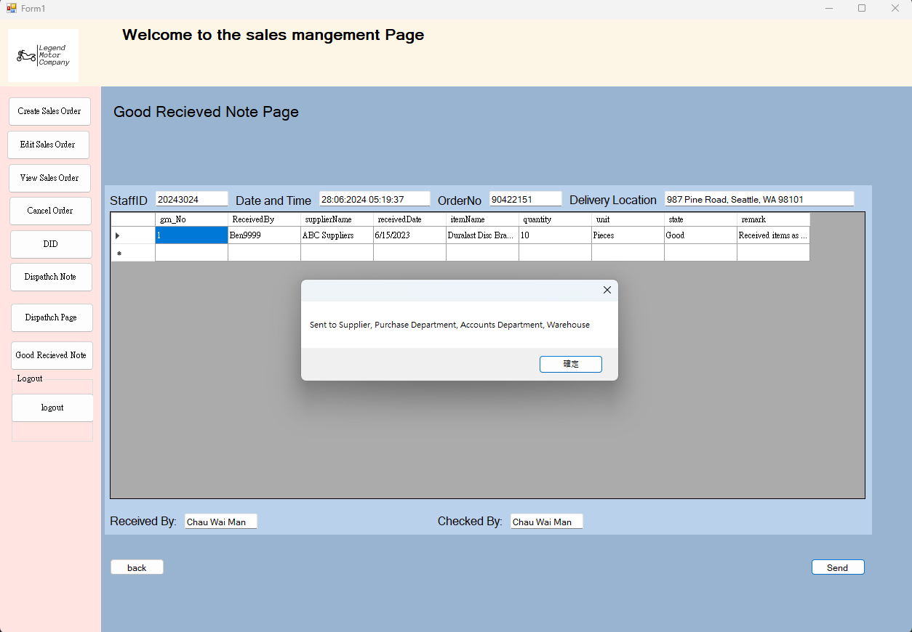

After sales managers click the “Send” Button, copies of Good Received Note will be send to Supplier, Purchase Department, Account Department and Warehouse

DID user guide

Sales managers can create a dispatch instruction detail with order details. After information is entered, sales managers can press the “Generate” button, and the and the system will generate a DID receipt and show the receipt on the right side.

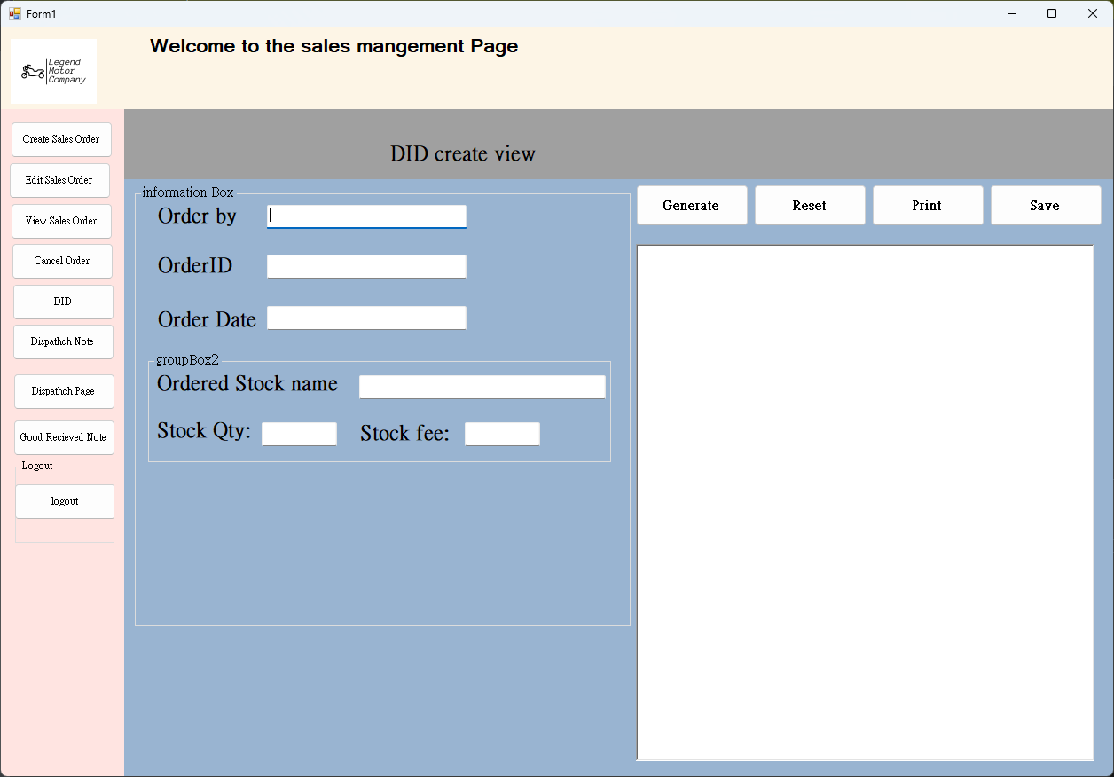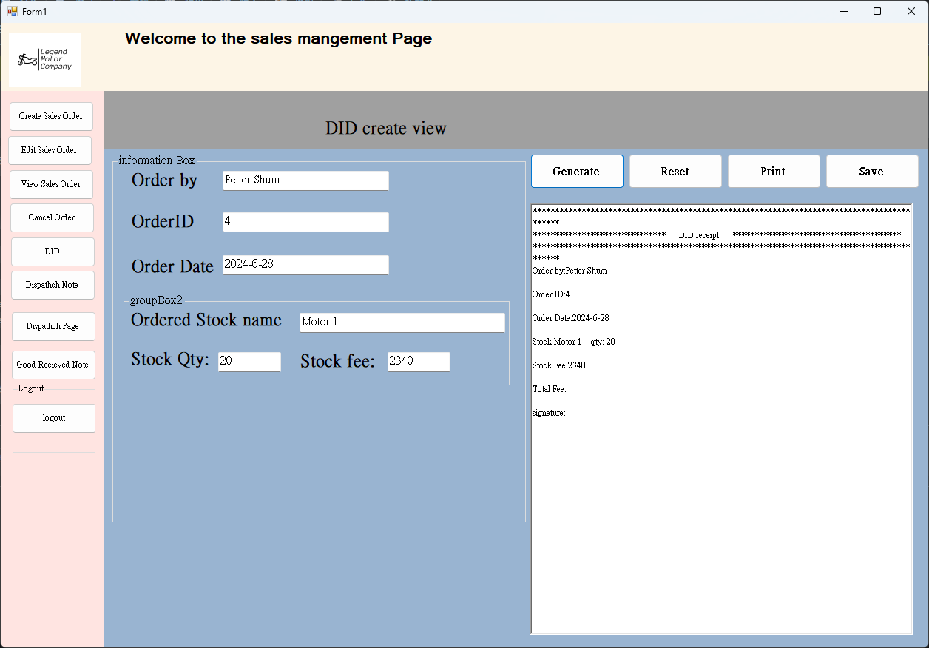

After all the required information is entered, press the "Save" button to save the DID receipt into the system database.

Stock record user guide:

Login as stock record staff in login user interface

as example input:

username(Tam2123456) and password(ABc123456)

And then view the main menu

those are function button which is use for the user going to other page

Logout account button

View stock button Main view stock screen

Click the View stock to show the Stock type button

Functional button (Danger level)

Click the function button danger level and this screen will be showed

Update stock danger level Add new stock danger level

Update button Add new button

Update required data input box Add new stock required data input box

Functional button (re-order)

All the Re-order Stock input boxes and all input boxes are required

Submit re-order detail

Back to main menu

Go to View re-order process

Functional button (View re-order process)

Search box

View-order process (process, delivery, completed)

Back to main menu

Current Stock record page:

Column name

Example other page show up: (stock Type 2)

Example other page show up: (stock Type 3)

Example other page show up: (stock Type 4)

**Limitation:**

Login:

* After the admin resets the user password cannot automatically send an email to notify the user their password has been reset.
* Sales System:
* Placed order will require staff to announces other departments or order process
* The system will not record the DID or the order receipt in the database. If the user want to record the DID or the receipt, user are required to save in there own device
* The system will not announce the order is completed or not. There will require staff to send the message or announcement.
* In the create order page it cannot place an order that has over 5 items/product. After clicking the add more button it will not add more textboxes letting user order more items/products.

Stock Record system:

* Danger level sorting. The system cannot sort the danger level
* No announcement for remind user re-order stock, order income and some stock are in danger level.
* no message will be show in processing re-order and ordering process position
* the system are will not remind the user that some stock is in danger level.

Additional Limitation:

# 7. Conclusion:

In conclusion for this report, we summarize the system problem in the company and suggested some solution or improvement in different aspect. Due to the current situation of the company, computerized and create a new and efficient database is one of the solutions. Our report’s plan will help to reduce the manual error, data and order processing. Eventually, let the company reduce unnecessary payment, increase market sharing and stock and data management.

By embracing computerization and establishing an optimized database, the company can address the existing issues, particularly in terms of manual errors, data management, and order processing. The proposed solutions outlined in our report provide a comprehensive and well-thought-out plan to tackle these problems head-on.

The introduction of a computerized system will greatly reduce manual errors, ensuring greater accuracy and reliability in data processing. This, in turn, will lead to improved order processing efficiency, enabling the company to meet customer demands more promptly and effectively. With streamlined operations and improved order management, the company will be able to minimize unnecessary payments and optimize financial resources.

Furthermore, the implementation of a new and efficient database will revolutionize the company's stock and data management capabilities. By centralizing and organizing information, the database will facilitate faster access to crucial data, enabling better decision-making and resource allocation. This enhanced efficiency in stock and data management will not only contribute to cost savings but also provide a competitive advantage in the market.

Overall, the improvement will not only address the specific system problem but also contribute to company’s long-term development and success by providing a solid foundation for effective and efficient operations. And about the project and the system that we are going to design and implement, it is based on the current drawback and the company situation, eventually decide to suggest embracing computerization and establishing an efficient database and operation system, the company will lay a solid foundation for effective and efficient operations, fostering growth and sustainability as a long term development.

# 8. References:

<http://chihleeir.lib.chihlee.edu.tw/bitstream/310993300Q/2162/2/%E5%A0%B1%E5%91%8A%E6%9B%B8.pdf>

<https://ankpal.com/blogs/what-is-order-processing-5-steps-10-tips-to-improve>

*What Is Order Processing? 5 Steps & 10 Tips to Improve | Ankpal Technology*. (n.d.). https://ankpal.com/blogs/what-is-order-processing-5-steps-10-tips-to-improve

<https://dl.acm.org/doi/abs/10.14778/1453856.1453890>

Li, J., Tufte, K., Shkapenyuk, V., Papadimos, V., Johnson, T., & Maier, D. (2008). Out-of-order processing. *Proceedings of the VLDB Endowment*, *1*(1), 274–288. https://doi.org/10.14778/1453856.1453890

<https://www.tandfonline.com/doi/abs/10.1080/21645515.2019.1607130>

Iwu, C. J., Jaca, A., Abdullahi, L., Ngcobo, N., & Wiysonge, C. S. (2019). A scoping review of interventions for vaccine stock management in primary health-care facilities. *Human Vaccines & Immunotherapeutics*, *15*(11), 2666–2672. https://doi.org/10.1080/21645515.2019.1607130

<https://www.toppr.com/guides/principles-and-practice-of-accounting/inventories/inventory-recording-system/>

*Inventory recording system: periodic and perpetual inventory system*. (2019, November 26). Toppr-guides. https://www.toppr.com/guides/principles-and-practice-of-accounting/inventories/inventory-recording-system/

<https://www.udomain.hk/tc/service/opencloud-server-openstack-instant-setup-asia-hongkong?gad_source=1&gclid=EAIaIQobChMIyd2A55PwhAMVwwp7Bx10pwpfEAAYAiAAEgIjOvD_BwE>

<https://www.oracle.com/hk/cloud/costestimator.html>